# Week2 Binary Classification

## Introduction to Binary Classification

False positive, false negative =>great costs

ROC Curve( Receiver Operating Characteristic Curve): estimate of the relative cost of the two different kinds of mistakes, maximize the area under the ROC curve=> discriminate signal from noise

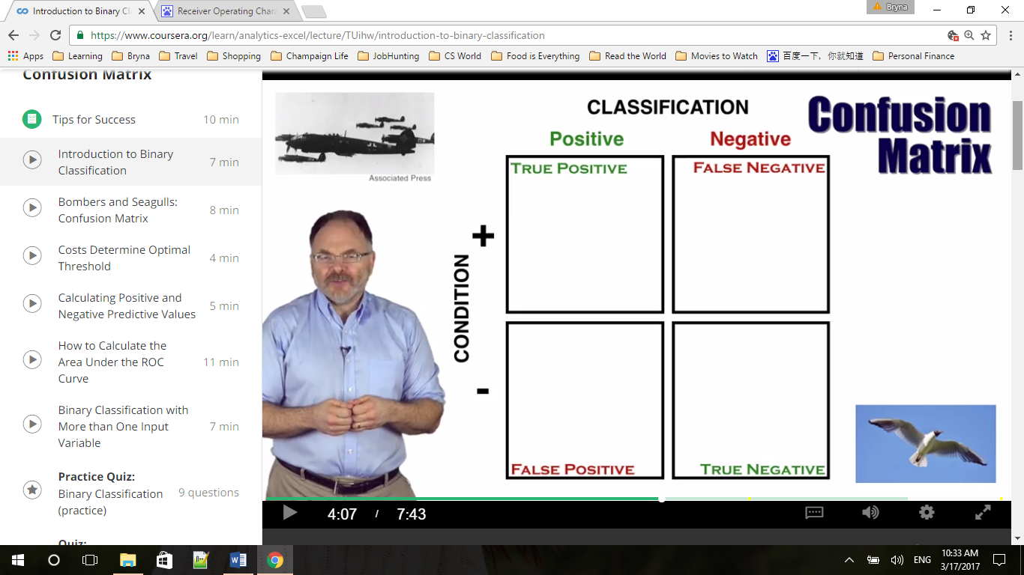

Note that a false positive rate is the total number of false positive classifications, divided by total number of seagulls. The true positive rate is the total number of true positive classification, divided by the total number of bombers.

FPR = FP/(FP+TN) 假正类率

TPR = TP/(TP+FN) 真正类率

TNP = TN/(FP+TN) 真负类率 1-FPR

Keeping the scoring method constant but changing the threshold leads to different values for the confusion matrix.

Area under the Curve of ROC (AUC ROC)

## Bombers and Seagulls: Confusion Matrix

Appendix: 2.1

First Use - Exploring the relationship between Classification Errors, the ROC Curve and the Area under the Curve (AUC)

Interact with the Bombers and Seagulls spreadsheet to see how changing the number of classification errors changes the false positive and true positive rates, the shape of the resulting Receiver Operating Characteristic Curve, and the overall Area Under the Curve (AUC).

On the Spreadsheet, ranked scores corresponding to the size of radar images are given in Column C, rows 33 to 52.

The actual condition – Bomber or Seagull – that goes with each score is given in Column D, rows 33 to 52.

This spreadsheet is a calculator that measures the number of incorrect and correct positive classifications at each threshold to generate a false positive rate – Column H, rows 32 to 52 – and a true positive rate – Column I, rows 32 to 52.

At each threshold dividing positive from negative classification, the false positive rate and true positive rate provide an (x,y) ordered pair. These ordered pairs, when shown on a chart and linked together, form the ROC Curve.

These ordered pairs are shown in Columns D and E, rows 6 to 26 – and are displayed on the chart at columns K-N.

The total area under the resulting ROC curve - the very important AUC Metric - is given in cell I28.

Try an experiment yourself – what if the event with radar score “83” had turned out to be seagull and not a bomber? This change would result in one more false positive classification and one fewer true positive classification for every threshold of 83 or below.

How would this impact the performance metrics for the radar? Replace the condition “1” in cell D37 with a “0.” Note that almost all the false positive and true positive rates at different thresholds change. You can observe how the shape of the ROC Curve on the chart changes, and how the area under the curve is reduced from .824 to .806.

Next, try changing the event with radar score 97 from a seagull to a bomber – by replacing the “0” in cell D33 with a “1.” This should improve the area under the curve from .824 to .906.

Second Use - exploring how changing the input “Costs per Classification error” changes the overall cost, and changes the optimum (lowest-cost) threshold

The Bombers and Seagulls Spreadsheet can also be used to observe how, keeping the threshold constant, changing the costs per false negative classification and per false positive classification changes the total cost of a classification system. It can also lead to a different threshold becoming the lowest-cost threshold.

Spreadsheet cell L30 contains the cost per False Negative (FN) – recall that this means failure to signal an alarm when bombers attack.

Cell N30 contains the cost per False Positive (FP) – the cost of responding to a false alarm.

The total costs over all 20 events, at each different possible threshold for binary classification, are given in Column O, rows 32 to 52.

The minimum total cost – the cost if selecting the “optimum” threshold – is given in cell O54.

To identify the optimum threshold using this spreadsheet, find the row in Column O that has the same total cost as the minimum cost given in row 54. Cell P54 shows the lowest average cost per event - the total cost, divided by the total number of events.

At the default settings of 10 million pounds per FN and 4 million pounds per false positive, the minimum total cost - 20 million pounds – is found in cell O40, which uses the Excel “min” function on the list of totals.

Now look across the spreadsheet to column C in the same row. Cell C40 shows that the optimum threshold at the default costs levels classifies 75 and above as “positive” and 74 and below as “negative.”

The total cost of 20 million pounds is due to 5 False Positive errors at 4 million pounds each, and 0 False Negatives errors at 10 million pounds each. The classification errors can be seen in Column D, rows 33, 35, 36, 38 and 39.

Now, try changing the cost per FN in cell L30 from 10 million pounds to 5 million pounds. Keep the cost per FP the same for now.

The new minimum total cost displayed in cell O54 is now 14 million pounds. Note that the minimum is no longer at 040. The new minimum-cost is found in cell O34. This corresponds to the threshold in cell C34. The new optimum threshold classifies 93 and above and positive and 90 and below as negative.

--------------------------------------------------------------------------------------------------------------------------------

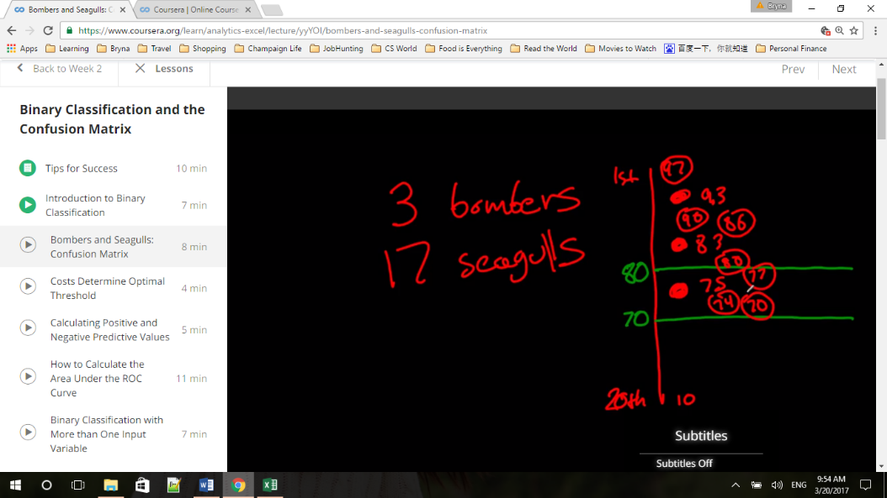The total cost of 14 million pounds is now due to one False Positive error (cell D33) at 4 million pounds and two False Negative errors (at cell D37 and D40) at 5 million pounds each.

Threshold => determine how many false alarms we have

80=> 4 false alarms, 97, 90, 86, 80; 2 true positive

70=> 7 false alarms, 97, 90, 86, 80, 77, 74, 70; all 3 true positive

Not radar but radar and a threshold => determine how many values go into each of these boxes

## Costs Determine Optimal Threshold

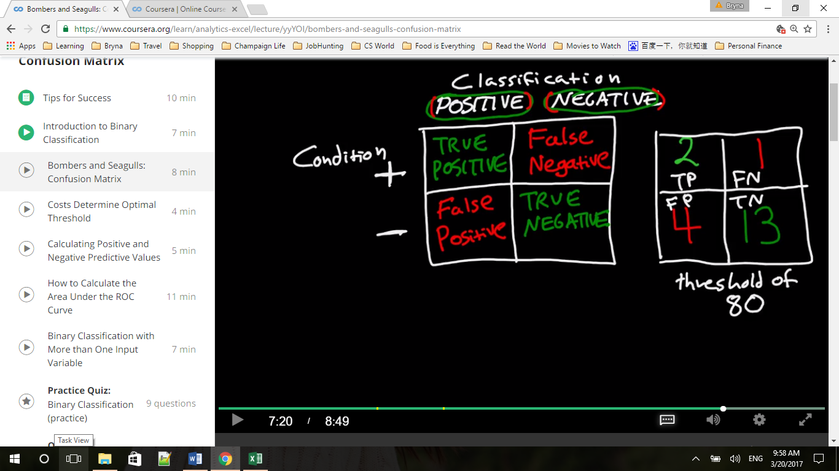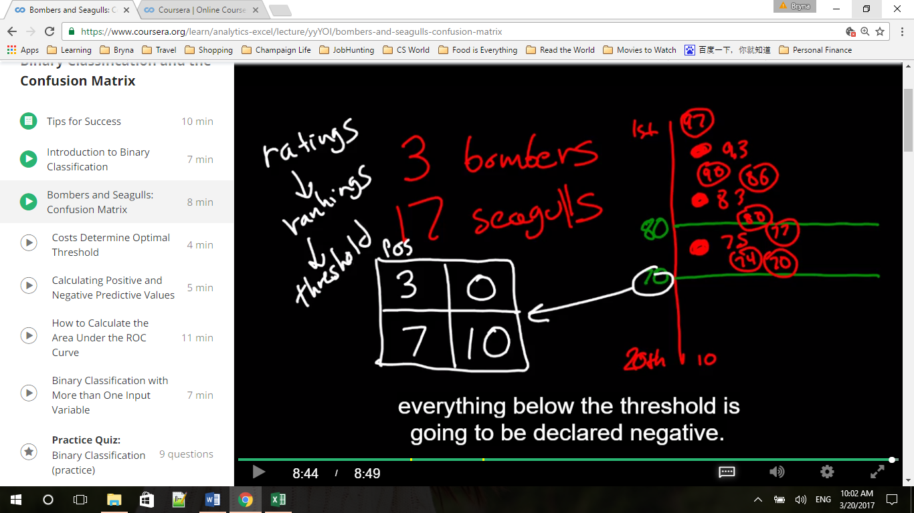

Threshold 80: FPR = FP/(FP+TN)= FP/Neg = 4/17 =

TPR = TP/(TP+FN) = TP/Pos = 2/3 =

Threshold 70: FPR = FP/(FP+TN)= FP/Neg = 7/17 =

TPR = TP/(TP+FN) = TP/Pos = 3/3 = 1

X = FPR, Y = TPR

## Calculating Positive and Negative Predictive Values

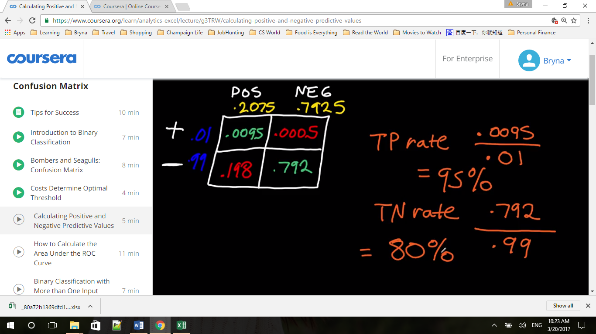

A true positive rate of 95% is conditional probability of having a having a positive test if I have cancer. And true negative rate is the p of having a negative test if I do not cancer.

What we want to know here is the latter: the conditional probability that we have the cancer if I have a positive test, or I don’t have cancer if I have a negative test?

P(POS TEST / + ) VS P( + / POS TEST)

P(NEG TEST/ - ) VS P( - / NEG TEST)

前者是说，我有病能测出来的准确率，后者是我测出来有病而我实际有病的准确率，不一样

计算方法：前者TP除以所有实际的True（上面两格）,后者TP除以测出来的Pos(左侧两格)

The latter is called positive predictive value (green yellow )

= 0.095/0.2075 = 4.58%, if I received a positive test, I have a 4.58% chance of having cancer

negative predictive value = 0.792/0.7925 = 99.937%, means that if the test turns out negative, I have 99.937% chance of not having cancer, 0.063% chance of having cancer

--------------------------------------------------------------------------------------------------------------------------------

Appendix 2.3

This spreadsheet works just the same way as the example shown in the Bombers and Seagulls Spreadsheet (and the video) but has 10,000 rows of data instead of 20. It is designed to provide a realistic simulation of the cost-benefit assumptions that must be made to set the classification threshold for a medical diagnostic product.

The ranked scores in Column A are the level of a certain protein as measured by the diagnostic test.

The true Condition for each protein level score is given in Column C [Cancer =1, No Cancer = 0].

A threshold for positive classification can be set between any two protein levels. For each threshold given in Column A, the resulting number of False Negative classification errors is given in the same row of Column H, and the False Positive classification errors in the same row of Column F.

This spreadsheet is designed to allow you to observe how changing cost inputs impacts both (a) the overall costs of using a cancer diagnostic test at each threshold, and (2) what threshold should be chosen as optimal (minimizing cost).

The cells to input the assumed costs of classification errors are Cell G3 for cost per False Negative (missing a case of cancer) and H3 for cost per False Positive (a false alarm). Total costs at each threshold are given in Column K.

The minimum total cost, and minimum cost per event (per diagnostic classification reported), are displayed in cells K4 and L4, and the optimum threshold – the lowest protein level score that should be classified positive - is displayed in cell M4.

At the default costs of $50,000 per False Negative error and $500 per False Positive error, the minimum cost per event is $119.90, and the optimal threshold for positive classification is 16551.930.

Try changing the inputs yourself. If you keep the cost per False Negative the same, but raise the cost per False Positive, would you in general expect the new optimum threshold to be higher (fewer total positive classifications) or lower (more total positive classifications)?

(In general, increasing the cost per FN while keeping the cost per FP constant will cause the cost-minimizing threshold score to: Increasing the cost per False Negative while keeping the cost per False Positive the same will move the threshold towards fewer False Negatives (and toward more False Positives). Then the question becomes "to reduce the number of False Negatives and increase the number of False positives, does the threshold move up (increase) or down (decrease)? decrease)

Change the cost per False Positive to $1500 and you will see that the optimum threshold is higher. The threshold for the first Positive classification moves from 16551.930 [item ranked 2094] to 16824.137 [item ranked 1822].

Similarly, if you reset the cost per FP at $500 and raise the cost per FN to from $50,000 to $500,000, the optimal threshold is lower – it falls to 13307.537 [item ranked 5338]

## How to Calculate the Area Under the ROC Curve

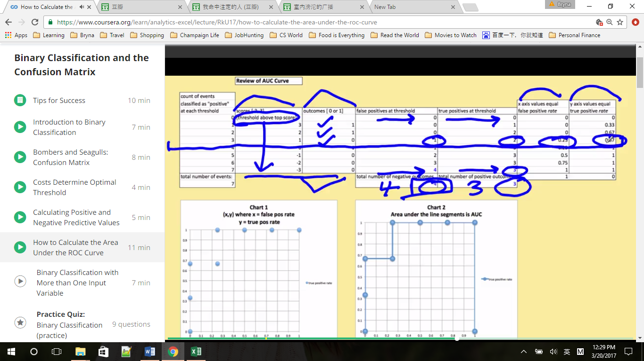

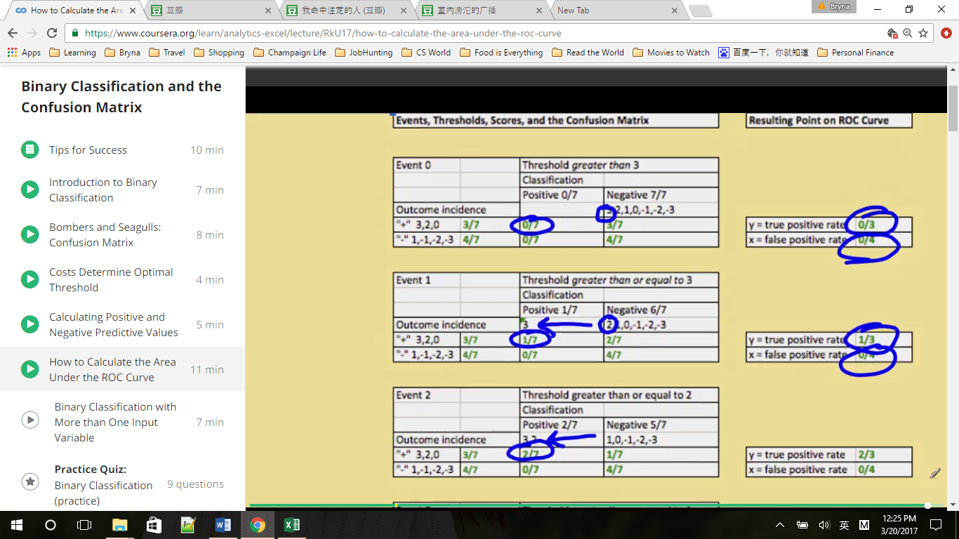

--------------------------------------------------------------------------------------------------------------------------------

Appendix 2.4

Input any value between 0 and 1 for the probability of True Positive classifications – the joint probability labeled letter e in the confusion matrix – into cell G9.

Next, enter any valid values (that is, any values less than or equal to the value entered into cell G9) for the condition incidence – letter a - (cell E9) and the “classification incidence” (also called “test incidence”) – letter c - (cell G7).

The Excel Spreadsheet will output:

-Values for the remaining five cells of the Confusion Matrix, designated by letters b, d, f, g, and h.

-Values for the eight primary performance metrics used to evaluate binary classification systems, Column F, rows 36-39 and 41-44.

-One point on the ROC Curve corresponding to this particular Confusion Matrix. Recall that the x-axis coordinate equals the False Positive Rate – output in Cell N37 – and the y axis coordinate equals the true positive rate – output in Cell O37.

Assume the Confusion Matrix shows the performance of a model that tries to predict which visitors to an Automobile dealership will buy a car from that dealer.

Experiment with how a change in one or more inputs impacts the outputs. For example, change the probability that an event will be a True Positive [Cell G9] to .18, without changing the condition incidence or test incidence.

Question: What is the conditional probability that a visitor classified as Positive by the predictive model (the “test”) will buy a car (the condition)?

Answer: 90%. The answer is the “Positive Predictive Value” – also written as the conditional probability p ("+" | Test POS) – as is found in cell F41, is 0.9.

Question: What point on the ROC Curve summarizes this confusion matrix performance? Answer:

Answer: (.03, .6). The value 3% is the False Positive rate – also written as the conditional probability p(Test POS | "-") – found in Cells N37 and F38. The value 60% is the true positive rate – also known as the conditional probability p(Test POS | "+") - Given in cells O37 and F36.

Question: What is the probability that a visitor classified as “Negative” by the predictive model will not buy a car from that dealer?

Answer: 85%. This value is the Negative Predictive Value, also written as the conditional probability p("-" | Test NEG) – found in Cell F44.

## Binary Classification with More than One Input Variable

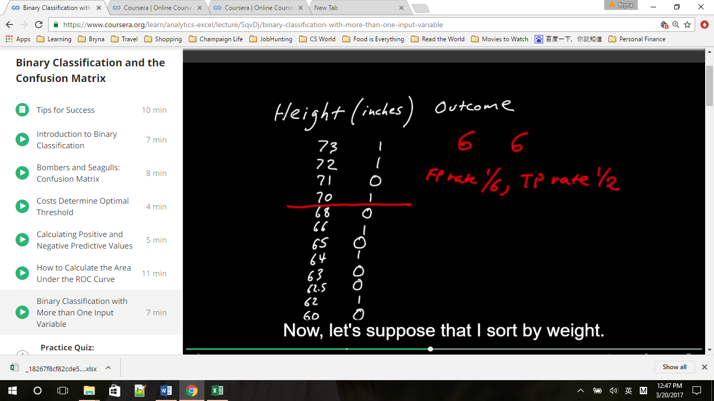 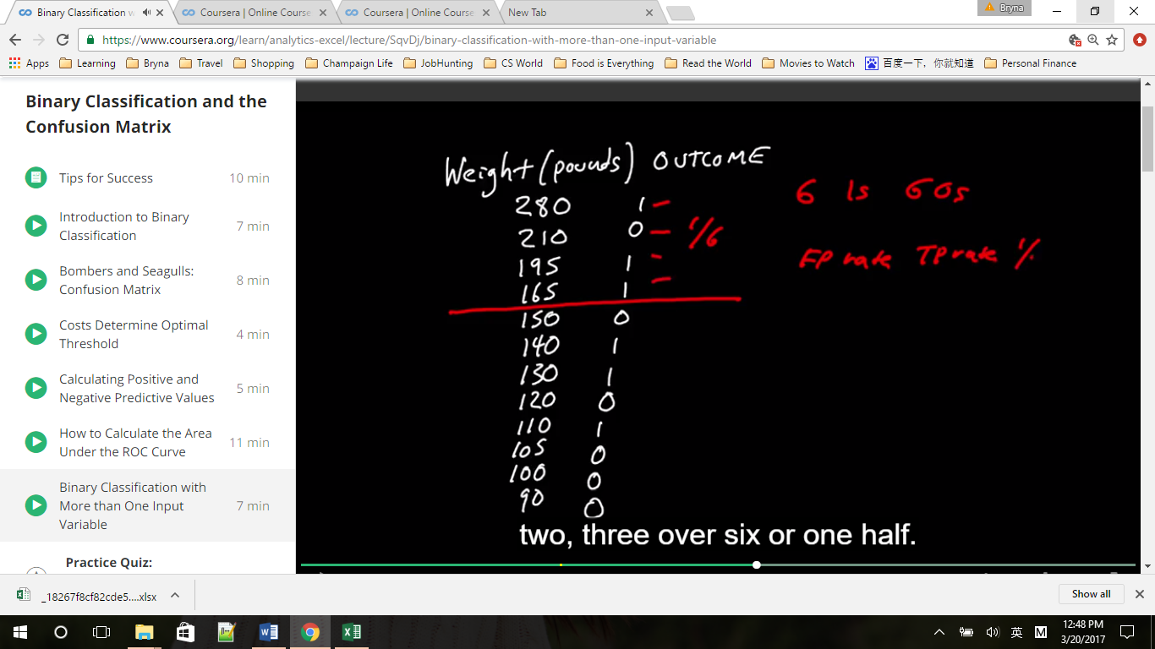

When you combine variables that have very different scales, first standardized them to figure out how much relative weight you should assign to each one. If we just add height and weight together, the weight swamp the results, nearly the same outcome based on weight only.

Why standardizing the data? To treat each of the two input variables as equally important

--------------------------------------------------------------------------------------------------------------------------------

Appendix 2.6

This Spreadsheet can be used to practice sorting data so that it is ordered by the “score” used for predictive purposes. Copy cells B18 to G30 and “paste special: values and number formats.” Past into the upper left hand corner of a new spreadsheet. Then select the right-most Column – containing the sum of standardized heights and weights – and choose Data/Sort/Descending – when asked, choose “Expand the selection.” You will now have created a ranked set of scores and outcomes, just like what is already provided in the Bombers and Seagulls and Cancer Diagnostics Spreadsheets. Repeat the process but sort on height alone, on weight alone, or on a combination of height and weight not previously standardized (Column G, rows 2 – 13) to compare the performance of the various scores when used for binary classification.

Assignment Questions:

Can a change in classification threshold change a diagnostic test's True Positive Rate? Use logic - no need to calculate any numbers.

* Yes. The number of Condition Positives is constant. But by moving one or more positive outcomes above or below the threshold the number of True Positive classifications changes. This changes the True Positive Rate, which is the ratio of True Positive classifications to total Condition Positives.

“Condition Incidence" is the portion of a population that actually has the Condition being studied. Can a change in threshold change the Condition incidence? Use logic - no need to calculate any numbers.

* No. Moving the threshold changes only classifications, not actual Conditions

Does the change in threshold change the test’s “classification incidence” (also called “test incidence”)? Use logic - no need to calculate any numbers.

* Yes. Moving the threshold down increases the proportion of outcomes classified as positive. Moving the threshold up reduces the proportion of outcomes classified as positive.

Does the change in threshold change the test's Area under the ROC Curve? Use logic - no need to calculate any numbers.

* No. Points on the ROC curve represent the false positive rate and true positive rate at each possible threshold. Changing the threshold signifies a different point on the ROC Curve, but does not change the overall shape of the curve.

# Week3 Information Measures

## Introduction to Measuring Uncertainty

### Probability and Entropy

Bayesian logical data analysis, P(X) is a measure of the degree of belief about the truth of the statement

P(A) = 1, the statement is true with certainty ; P(A) = 0, the statement is false with certainty

Probability distributions: collections of individual probabilities that sum to one

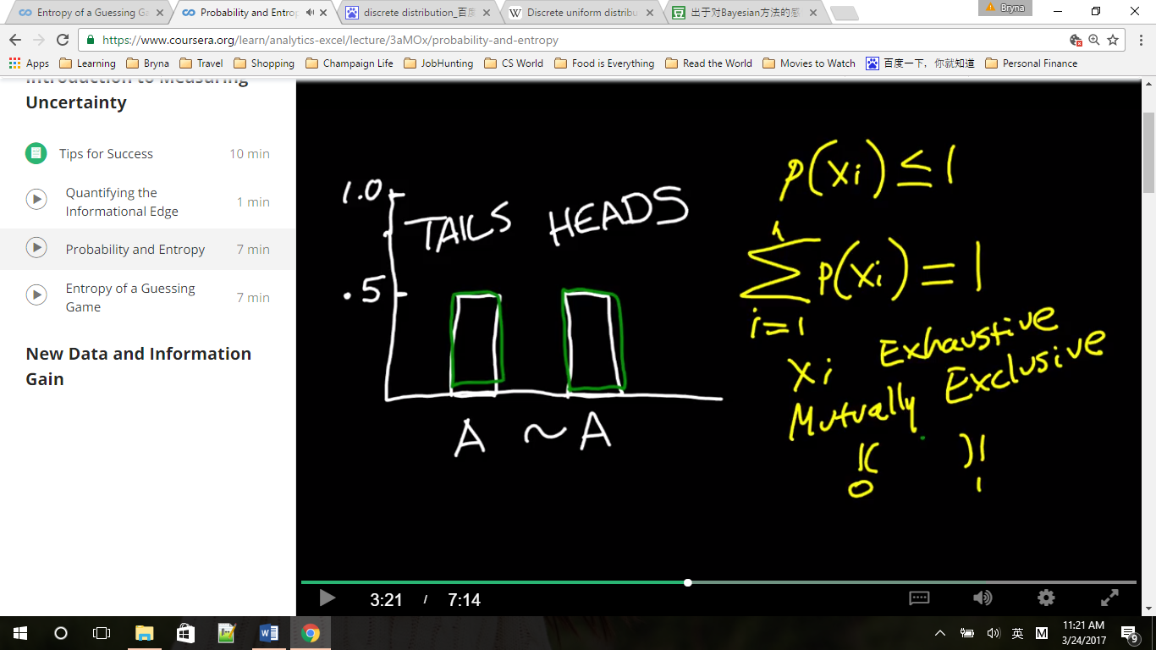

Exclusive, tails or heads; exhaustive, no third probability

H(X) is a measure of the uncertainty of the whole probability distribution measured in bits of information

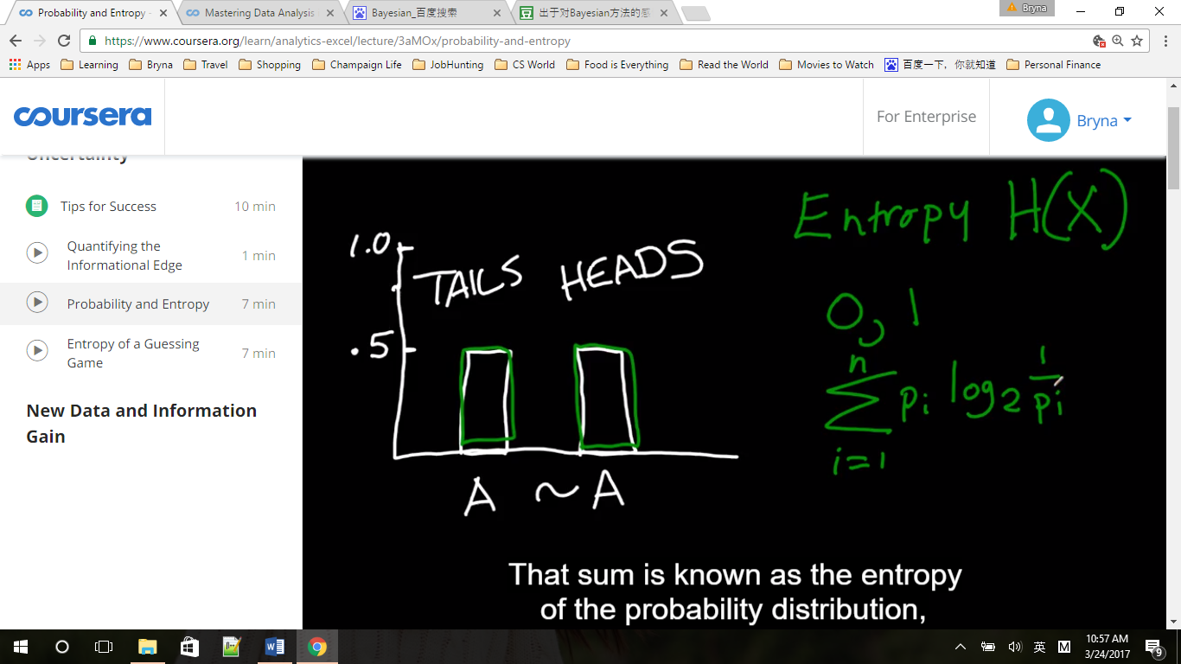

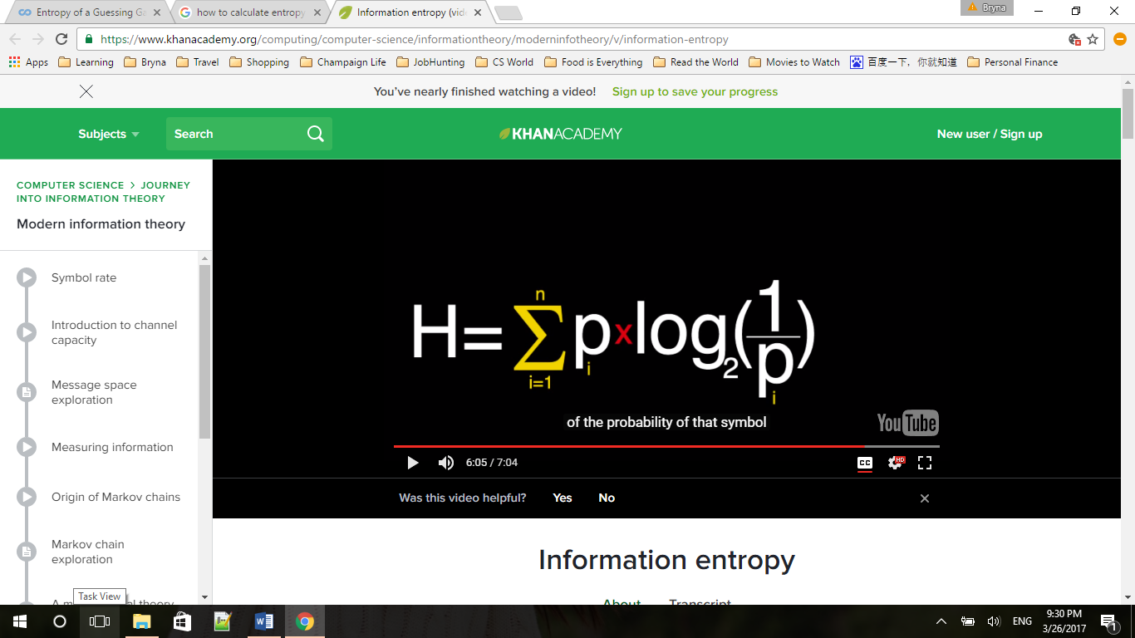 from Khan Academy

Entropy is the sum of each probability times the log to the base 2 of one over that probability

If we have a uniform distribution (均匀分布) with n possible outcomes, H(X) = log2n, also the maximum of entropy, other distribution will have a smaller H than a discrete distribution

(for example, tail or head, p =1/2, H(X) = 1/2*log2(1/(1/2)) +1/2*log2(1/(1/2)) = log22 = 1

Or p=1/6, H(X) = 6*( 1/6*log2(1/(1/6))) = log26

After we’ve thrown the coin, P(Tails) = 1, H(X) = 0

The more uncertainty we have, the bigger it gets, minimum at zero

### Entropy of a Guessing Game

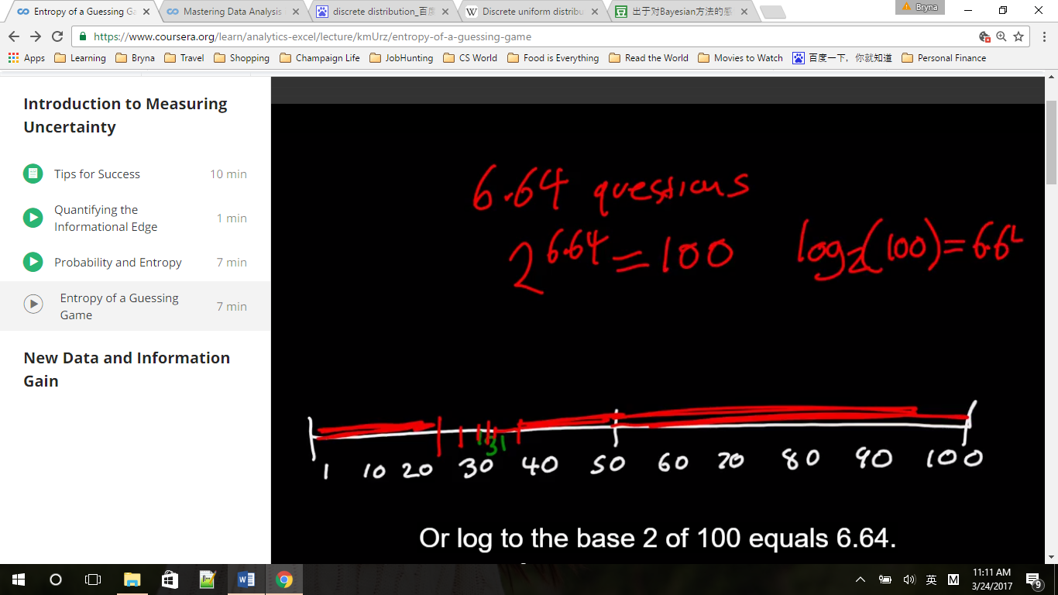

Now consider a guessing game where my friend picks a number between 1 and 100. And I need to guess what it is, asking only simple yes or no questions of the form, is your number bigger than x?

It will take me six point six four questions, on average, to get the correct answer.

Log2100 = 6.64, log210000 = 13.29 which is the entropy of the 10000 possibility game, also means at the beginning of the game my uncertainty can be quantified as 13.29 bits of uncertainty

The entropy of the joint probability H(e,f,g,h) = H(X,Y)

Conditional probability => conditional entropy

e/a, true positive rate, the conditional probability of having a positive test, if you have the condition

* Conditional entropy: the entropy of X conditioned on Y is written as H(X|Y).

在信息论中，条件熵描述了在已知第二个随机变量 Y 的值的前提下，随机变量X 的信息熵还有多少

|  |  |  |  |  |
| --- | --- | --- | --- | --- |
|  |  |  | Classification/Test Y | |
|  |  |  | Pos | Neg |
|  |  |  | c | d |
| Outcome X | + | a | e | f |
|  | - | b | g | h |

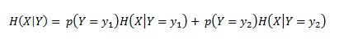

H(X|Y) = P(Y=Y1)H(X|Y=Y1) + P(Y=Y2)H(X|Y=Y2)

= c*H(e/c,g/c)+d*H(f/d,h/d)

## New Data and Information Gain

### Dependence and Mutual Information

We measure the mutual information by measuring the uncertainty we start with regarding x, that's H(x), and then subtracting out the uncertainty that remains for x after we learn y

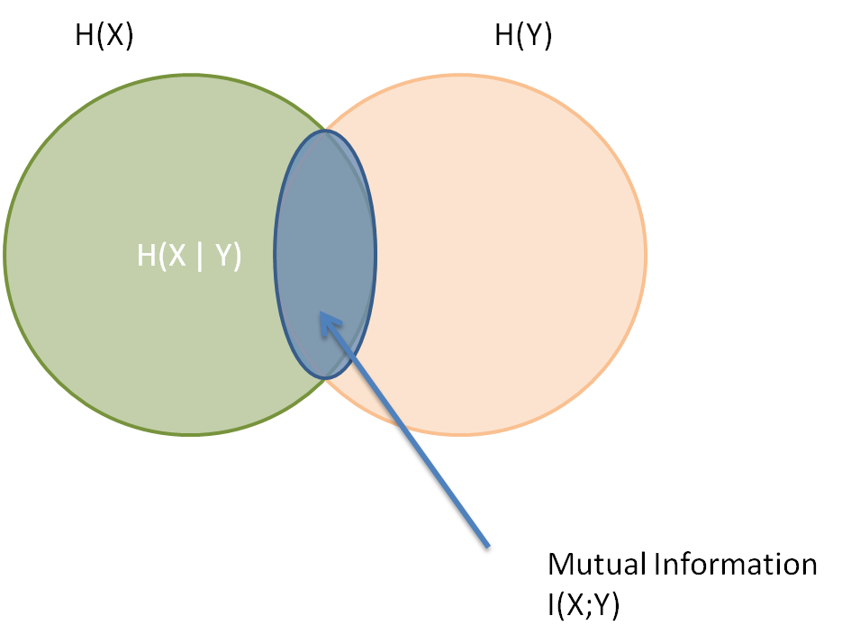

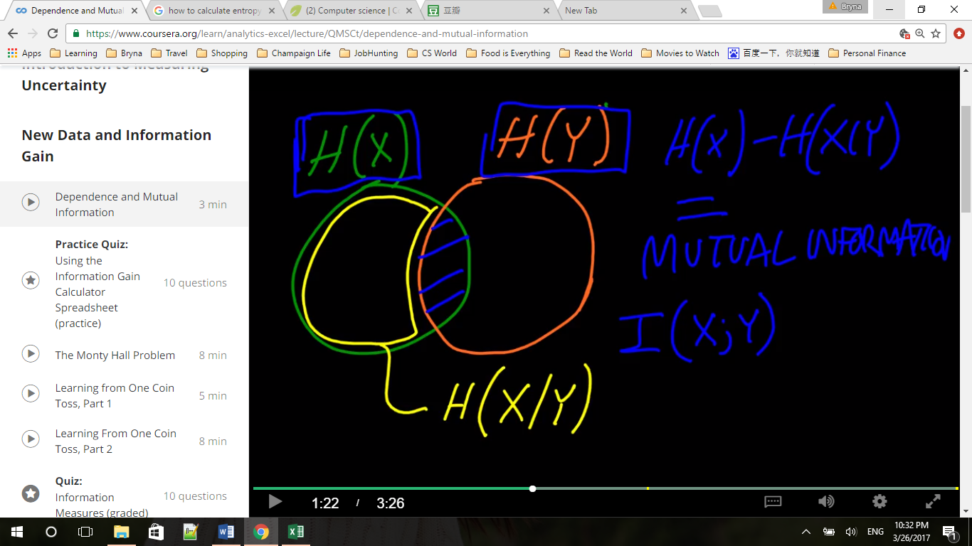

* Independence and dependence of probability distribution

Independent: joint distribution = product distribution, P(X,Y)= P(X)P(Y)

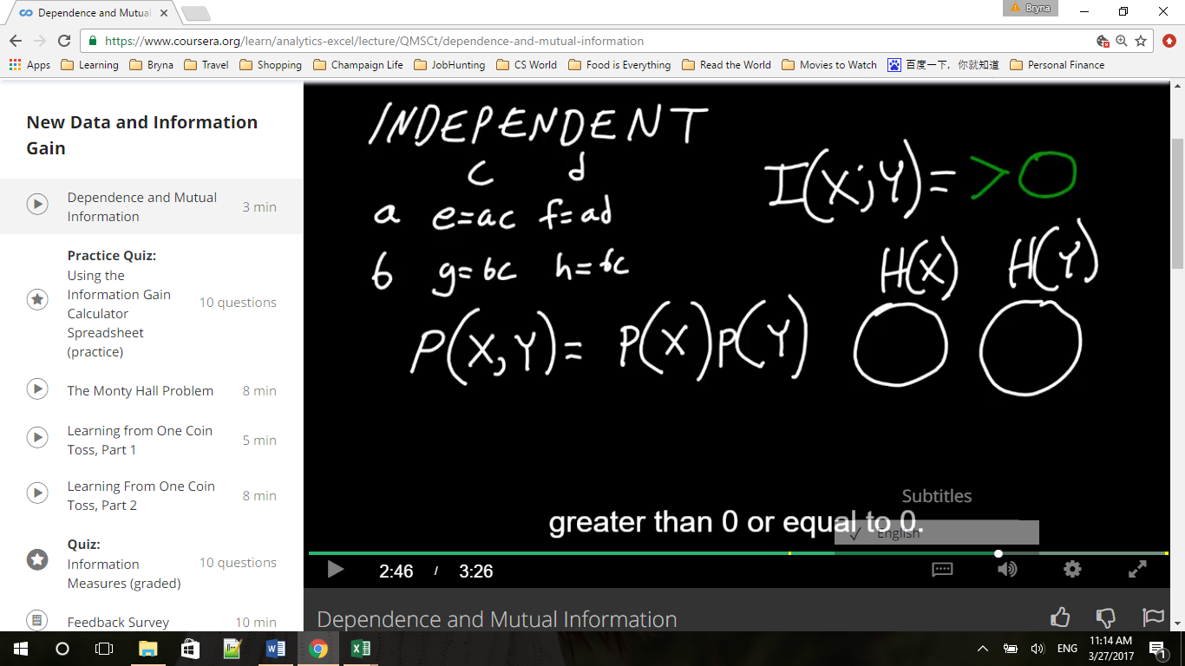

Correction: h = bd

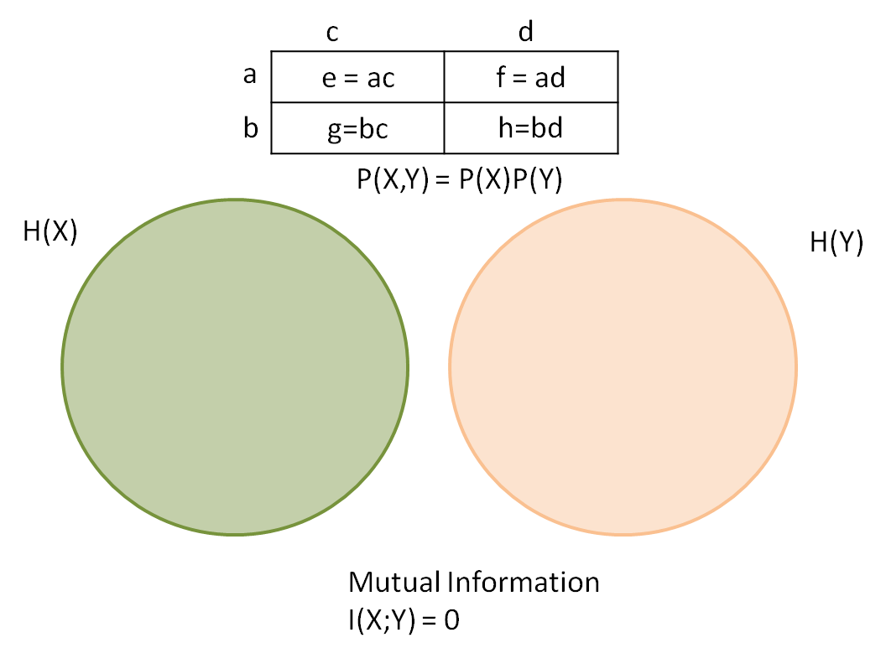

If dependent, P(X,Y)!= P(X)P(Y), I(X;Y)>0;

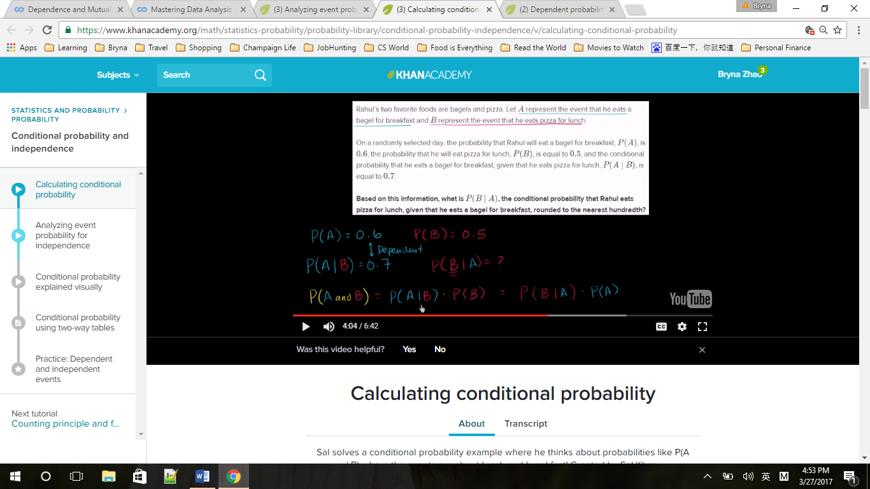

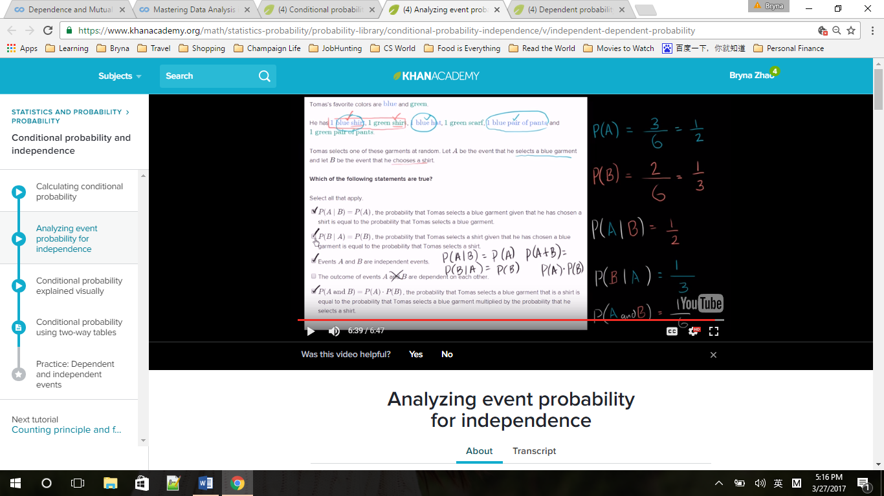

### Information Gain Calculator

Imagine a massive factory assembly line that manufactures computer microchips. The factory produces tens of millions of chips per year. Defective chips have in the past been discarded after electronic testing, which is very accurate, but slow and expensive. Based on the “gold standard” of electronic testing, 20%(a) of chips are found to be defective and are discarded.

If it were possible to identify and discard some or all of the defective chips without the need for electronic testing, chip production costs would be much lower. Factory Management installs an optical scanner on the assembly line that photographs the chips while they are moving down the assembly line. The scanner software identifies shapes that vary by more than a specified amount from a standard template. The scanner can forecast which chips are defective without slowing down the assembly line.

However, optical scanning is not perfect – there will always be some false positive and false negative classifications. Consider the default values given in the spreadsheet. When the optical scanner is installed, and is set to classify the top 30% (c)of measured shape variations as positive for defects [cell G7] the test’s false positive rate is 25% [cell F38] and its false negative rate is 50% [cell F37].

Uncertainty about whether a chip is defective or not, before it is scanned, can be measured: H(.2,.8), H(X) = .7219 bits [cell O9].

Uncertainty about whether a chips is defective or not, after it is scanned and classified, is H(X|Y) = .3*H(1/3, 2/3) + .7*H(.14, .86) = .6896 bits [cell L45].

The reduction in uncertainty between the two is the “Mutual Information” between X and Y, written I(X;Y). This is H(X)-H(X|Y) = .7219 - .6896 = .0323 bits [Cell P17].

Taking the ratio of mutual information obtained to entropy before scanning, .0323/.7219, gives a 4.47% Reduction in Uncertainty; also called the Percentage Information Gain [P.I.G.].

Changing Spreadsheet Inputs

This Spreadsheet allows you to create any valid Confusion Matrix. Input three values:

Condition Incidence (labeled a) [cell E9],

Test Incidence (labeled c) [cell G7], and

Joint Probability that a classification will be a True Positive (labelled e) [cell G9].

*The Spreadsheet automatically calculates all other Confusion Matrix values.

Try for yourself what happens to the performance metrics when the defect-forecasting software in the optical scanner is improved so that only 15% of chips are classified positive [cell G7], while the probability of a true positive classification remains constant at 10%.

The false positive rate falls from 25% to 6% [cell F38] while the false negative rate is unchanged.

The new uncertainty about whether a chips is defective or not, after it is scanned and classified, is less - .5819 bits [cell L45].

The new “Mutual Information” between X and Y, is more - .7219 - .5819 = .14 bits [Cell P17].

The new P.I.G is also higher - 19.39% [cell O11].

Determining Dependence or Independence of two Probability Distributions

The spreadsheet demonstrates multiple ways to calculate the Mutual Information between two binary probability distributions, including comparing their Joint Distribution [cells L28 to S 28] and their Product Distribution [cells L 29 to S 29].

When the joint distribution and the product distribution of two probability distributions X and Y are identical, then knowledge of X provides no reduction in uncertainty about Y, and vice versa. When the Mutual information between the two distributions is zero. This state is called “independence.”

Try it for yourself: enter the product of a and c, (p(X = +)*p(Y = POS)) = (.2)(.3) = .06 into the cell labeled e [G9].

Note first that the three other joint distributions in the Confusion Matrix [cells L28 to S28] all become equal to their product distributions [cells L29 to S29]. When every value in a joint distribution p(X,Y) equals the product distribution p(X)p(Y), the Mutual Information and Percentage Information Gain equal zero.

In addition, because there is no intersection I(X;Y) between the regions H(X) and H(Y) in the Venn Diagram [Columns W-AH] , the sum H(X) [cell L17] plus H(Y) [cell L21] equals H(X,Y), 1.6032 bits [cell L26].

### The Monty Hall Problem

The probability that the prize is behind door one remains at one-third just like it was when that door was first chosen

Because Monty Hall is very constrained in what he can do. He cannot open the door that has been chosen by the contestant and you cannot open the door that's got the valuable prize behind it, two-thirds of the time Monty is signaling where the prize is, we just don't know which two-thirds

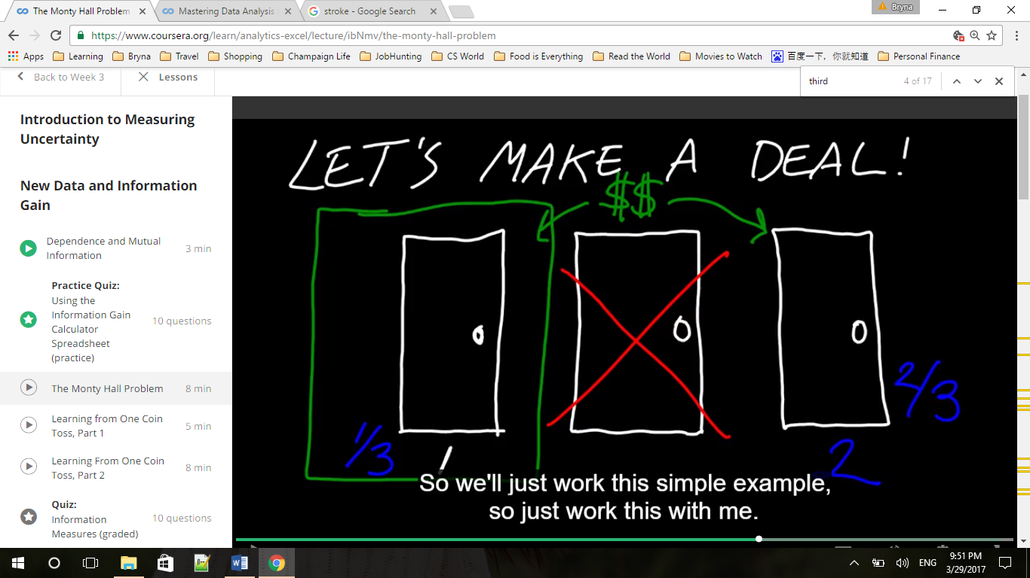

P(X)= (1/3, 1/3, 1/3)

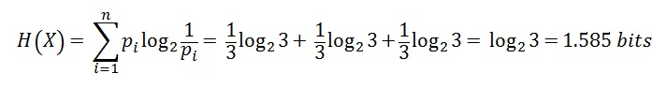

H of X given Y, H(X|Y)=

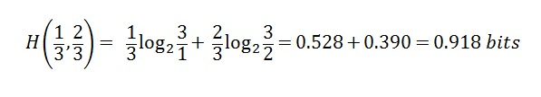



Monty has provided us with 0.667 bits of information by opening one door.

P.I.G.= 0.667/1.585=0.421

### Learning from one coin toss

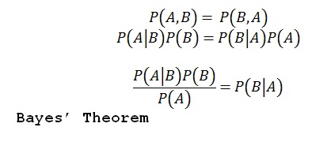

Probability distributions are carriers of information

Inverse probability problem:

Probability of B given A is the value that we want to know. The probability that the coin in fair given that the coin came up tails.

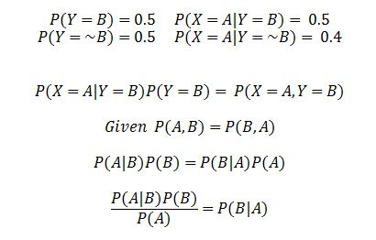



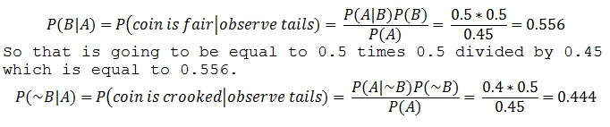

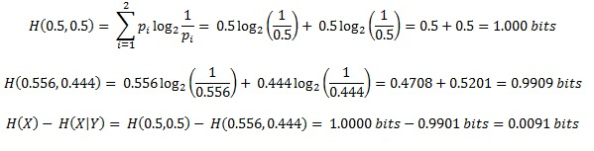

Quiz:

B stands for “the coin is fair”, ~B stands for “the coin is crooked”. The p(heads | B) = 0.5, andp(heads | ~B) = 0.4. Your friend tells you that he often tests people to see if they can guess whether he is using the fair coin or the crooked coin, but that he is careful to use the crooked coin 70% of the time. He tosses the coin once and it comes up heads.

What is your new best estimate of the probability that the coin he just tossed is fair?

P(B)=0.3,P(~B)=0.7

P(A|B)=0.5,P(A|~B)=0.4

P(A)=P(A|B)*P(B)+P(A|~B)*P(~B)=0.5*0.3+0.4*0.7=0.43

P(B|A)=(P(A|B)*P(B))/P(A)=0.349

Suppose you are given either a fair dice or an unfair dice (6-sided). You have no basis for considering either dice more likely before you roll it and observe an outcome. For the fair dice, the chance of observing “3” is 1/6. For the unfair dice, the chance of observing “3” is 1/3. After rolling the unknown dice, you observe the outcome to be 3.

P(A|B)=1/6, P(A|~B)=1/3,P(B)=P(~B)=1/2

P(A)= P(A|B)*P(B)+P(A|~B)*P(~B)=1/6*1/2+1/3*1/2=1/4

P(B|A)=1/3

What is the new probability that the die you rolled is fair?

Quiz: consider the Monty Hall problem, but with 5 doors to choose from instead of 3. You pick door #1, and Monty opens 2 of the other 4 doors. How many bits of information are communicated to you by Monty when you observe which two doors he opens?

Initial distribution is .2, .2, .2, .2, .2.

Distribution after learning from Monty is .2, .4, .4.

H(1/5,1/5,1/5,1/5,1/5)= log2(5)=2.32

H(1/5,2/5,2/5)=1/5*log2(5)+ 4/5*log2(5/2)=1.52

# Week4 Linear Regression

## Introduction to Parametric Models

### 1.1 Introducing the Gaussian

A good model includes both a signal and noise

Gaussian Probability Density Function: the most common model for noise or uncertainty used in data analysis

### 1.2 Introduction to Standardization

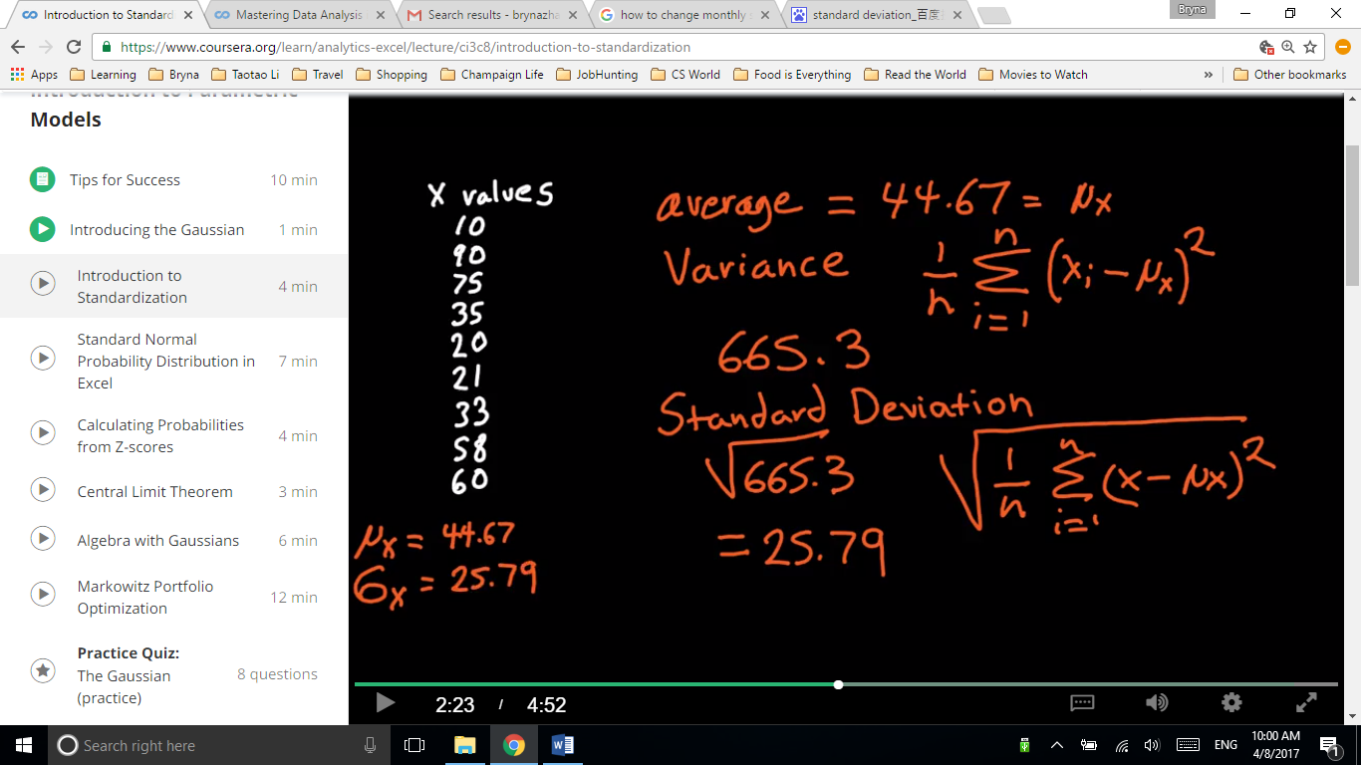

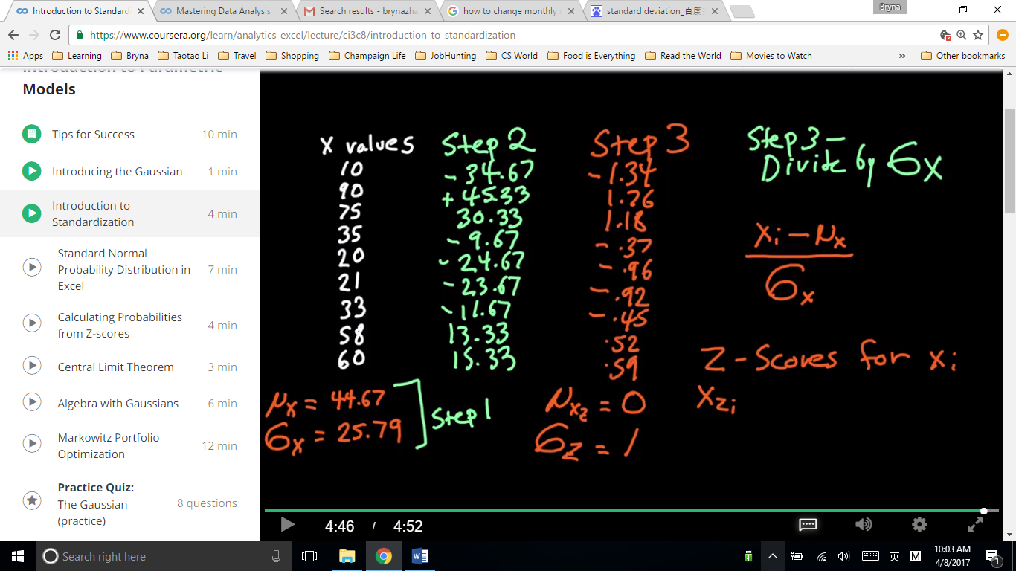

Step 1: calculate mean, variance and standard deviation 方差和标准差

Step 2: minus mean (μx)

Step 3: divide by sd (σx)

Xzi = Z score for Xi = (Xi - μx)/ σx

μxz = mean of all the Xzi = 0 所有z-score的平均数为0，标准差为1

σz = 1

Appendix 4.1

This Spreadsheet demonstrates the three-step process to convert any set of numbers into a set of Z-scores. This process is called “standardization” and the Z-Scores are the “standardized” version of the original numbers.

Step One: calculate the mean [Cell B15] and standard deviation [Cell B16] of a set of numbers (here, the set of numbers is in cells B5 to B13).

Step Two: subtract the mean of set [Cell B15] from each number. Results are in cells C5:C13. Note that the new mean of the modified numbers is 0 [Cell C15] The standard deviation remains unchanged [Cell C16].

Step Three: Divide each modified number by the original standard deviation. Results are in cells D5:D13. Note that the mean remains 0 [Cell D15] and the new standard deviation is now 1 [Cell D16].

You can copy the structure of the spreadsheet for sets of numbers (Columns) of any length

This spreadsheet also illustrates how the regression (best-fit) line for the original ordered pairs and the regression line for the pairs of z-scores differ and how they stay the same.

When ordered pairs are converted into Z-Scores:

-The correlation R [Cell F44] and Coefficient of Determination (R^2) [Cell F45] are unchanged.

-The new covariance [Cell F41] and the slope (beta) [Cell F42] both change to equal the correlation.

-The new Y-intercept (alpha) [Cell F44] always changes to 0.

----------------------------------------------------------------------------------------------------------------------------------------

Khan Academy

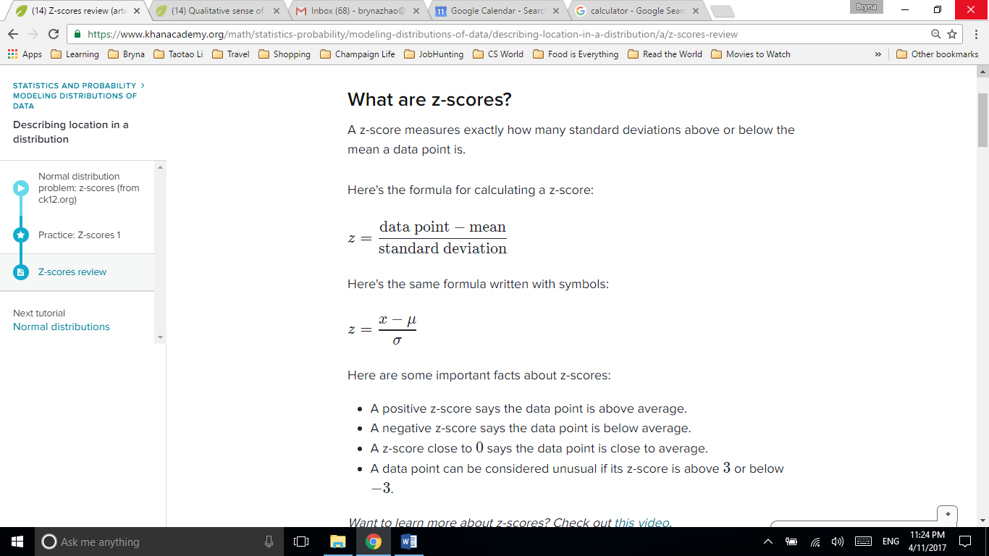

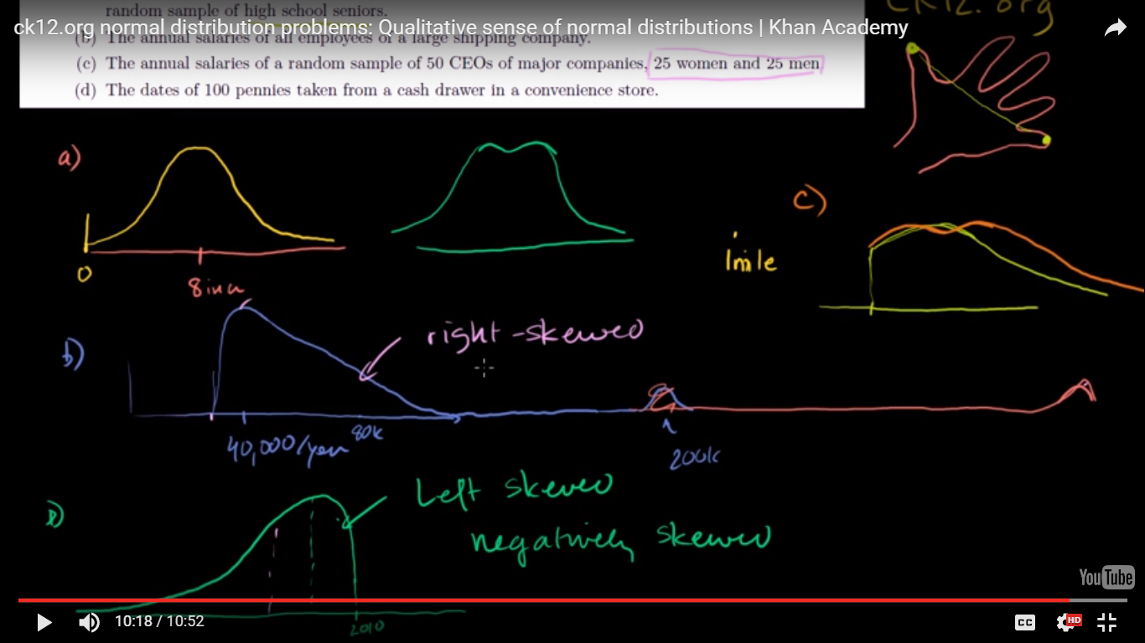

Right-skewed distribution: median < mean; left-skewed distribution: mean < median

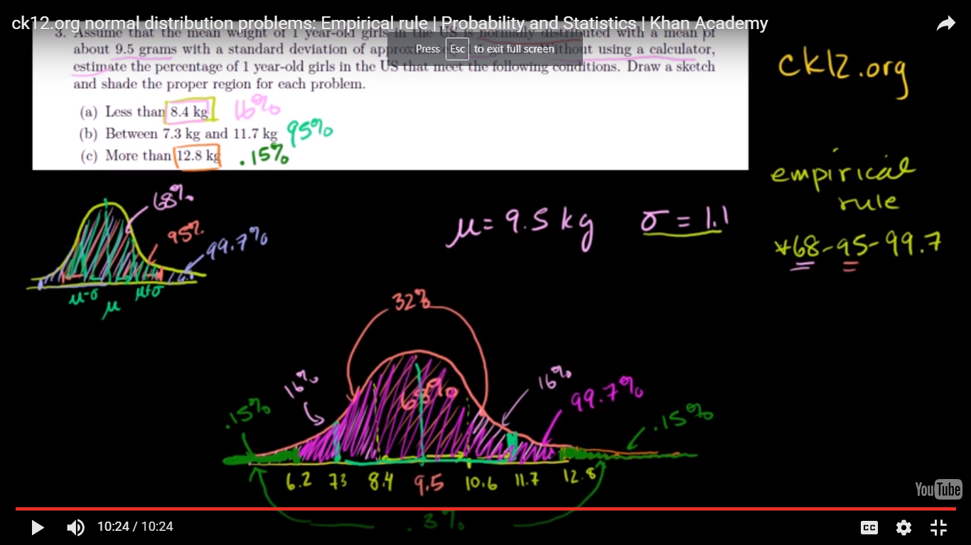

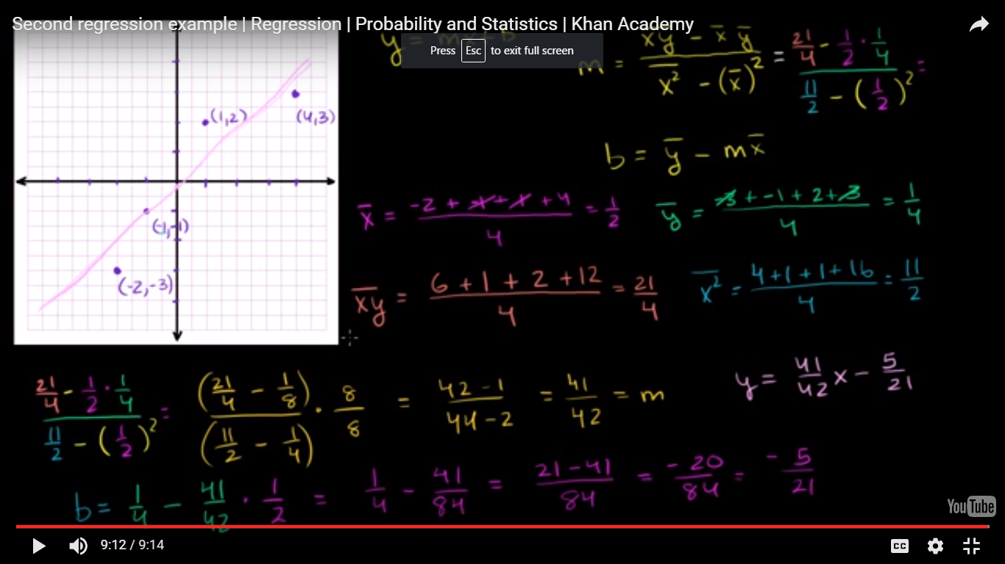

Minimizing squared error to regression line

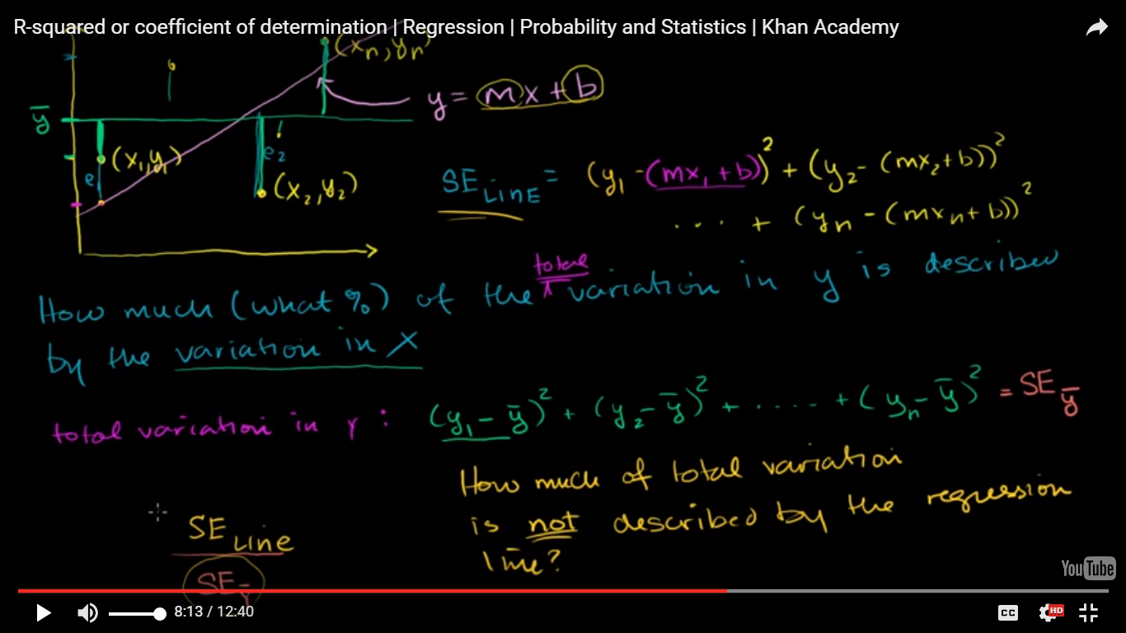

How much (what %) of the variation in y is described by the variation in x

SEline/ SEymean => how much of total variation is not described by the regression line

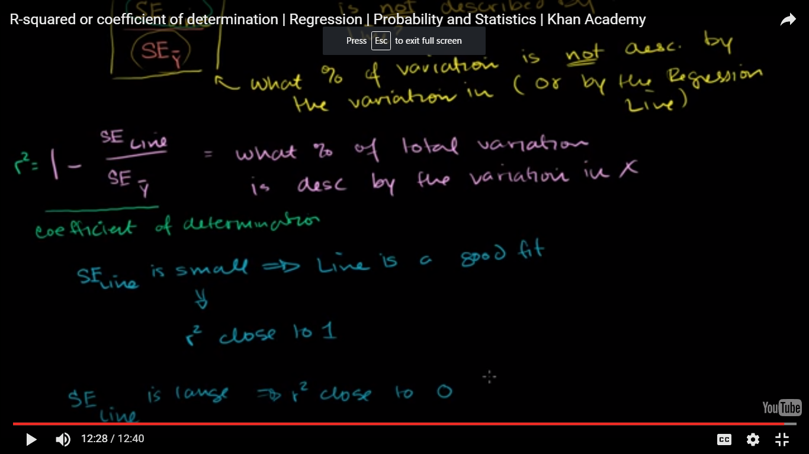

r2 => coefficient of determination

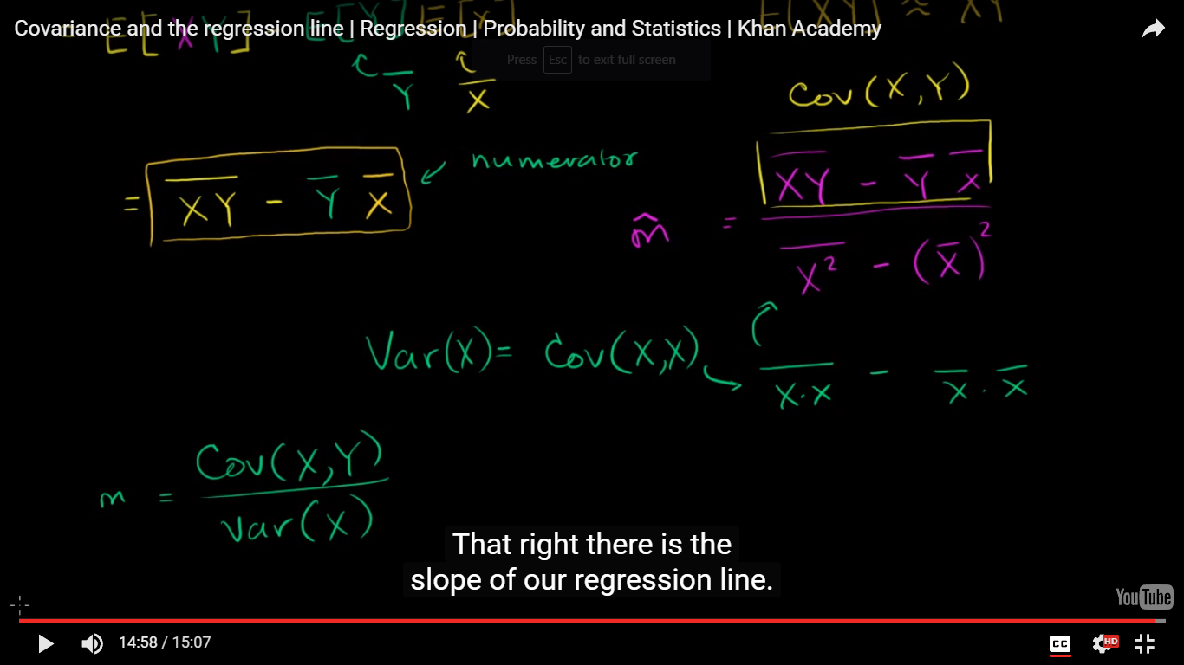

slope, m = Cov(x,y) / var(x), covariance of two random variables over the variance of x

<http://mathworld.wolfram.com/Covariance.html>

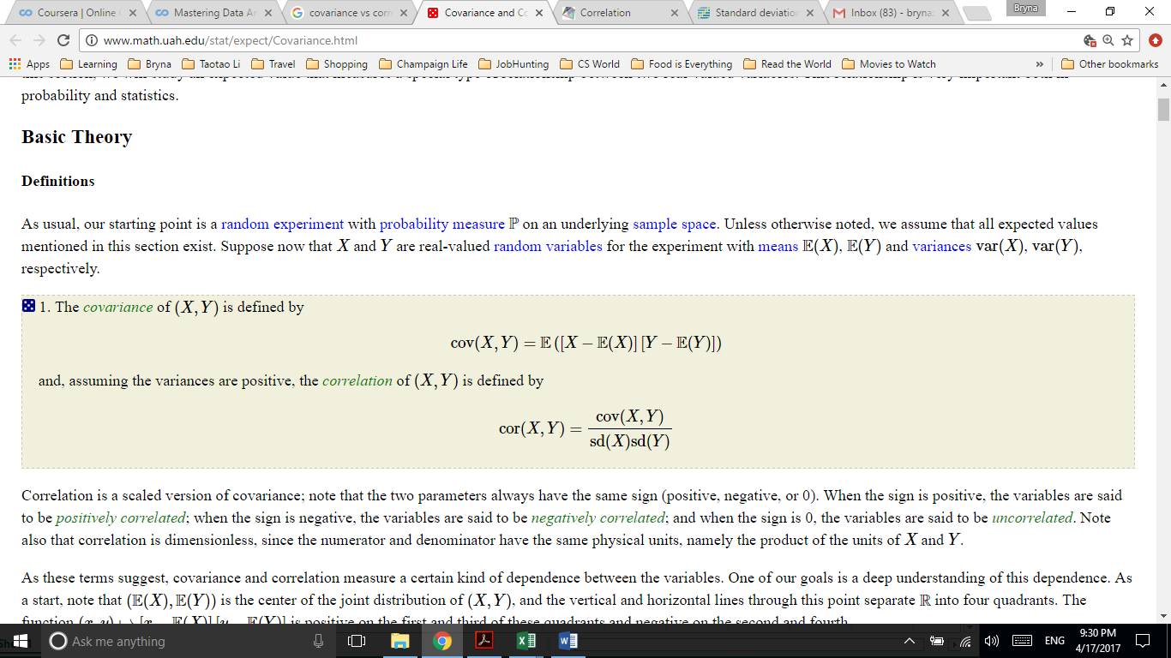

### Standard Normal Probability Distribution in Excel

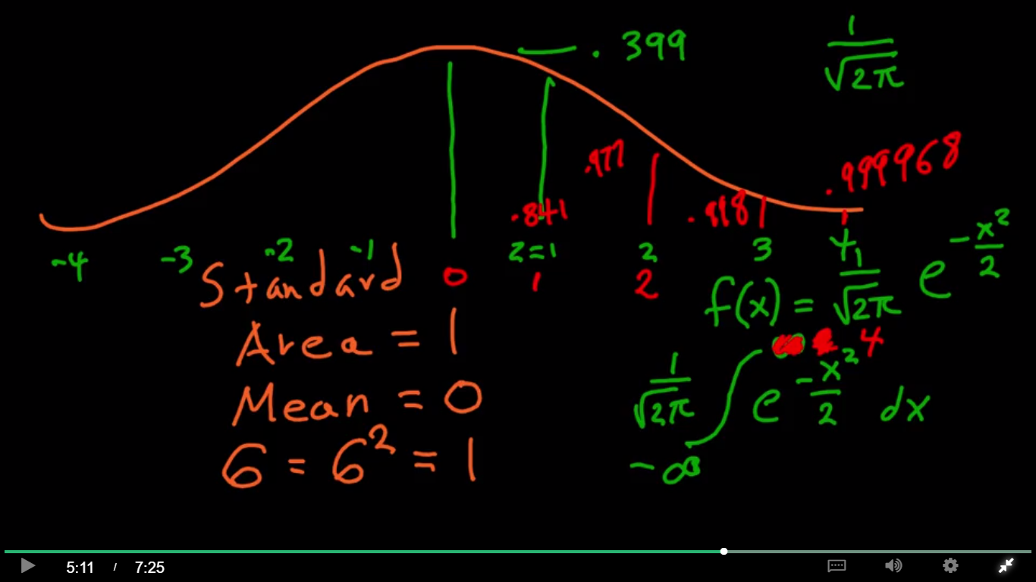

Excel:

NORMSDIST(z-score)=> probability

NORMSINV(p)=> z-score

Parametric model => regular input, output and noise, mostly Gaussian

Appendix 4.2

The Gaussian Standard Normal Distribution is shown in blue (on spreadsheet). The function that generates this curve is Standardized so that the total area under the curve equal is to 1, making the curve suitable to use as a probability distribution function (PDF).

The curve shown has mean 0 and its standard deviation equals 1.

For any value on the x axis (known as a z-score), the area under the curve to the left of that value is called the *cumulative probability* at that z-score.

Cumulative probability as a function of z-score is shown in red.

This spreadsheet shows, in Column C, for z-scores between -4 and 4 (99.9936% of all cases), the probability to the left of that z-score, called the *cumulative probability*. The Excel function that generates cumulative probability from a z-score (z) is NORMSDIST (z). The probability to the right of the z-score, (one minus the cumulative probability) is given in Column D.

It is also easy to convert a cumulative probability (p) into a z-score. This Excel function, the inverse of the NORMSDIST function, is called NORMSINV, and is shown in Column E.

**Solving problems.**

Example 1. To determine how probable is that an event drawn from a Gaussian Standard Normal Distribution is more than two standard deviations below the mean, calculate NORMSDIST(-2). The answer is the cumulative probability p = .023, or 2.3%. [Cell C32] The probability that an event is *not*more than two standard deviations below the mean, is one minus the cumulative probability, .977 or 97.7%. [Cell D32].

Example 2. Assume the average high school teacher in the U.S. is paid $28,000, with standard deviation = $3,000. What is the probability that a U.S. high school teacher is paid between $25,000 and $31,000?

Answer: First, convert the low end of the interval, $25,000, to a Z-Score. Z = ($25,000 – $28,000 )/$3,000 = -1.

The area under the curve to the left of -1 is .159. [Cell C42] There is a 15.9% chance that a teacher is paid less than $25,000.

Next, convert the high end of the interval to a z-score. z = ($31,000 - $28,000)/ $3,000 = 1. The cumulative probability at z = 1 is .841 [Cell C62] area under the curve to the *right*of z = 1 is (1- .841) = .159. [Cell D62].

There is a 15.9% chance that a teacher is paid more than $31,000. Therefore the probability that a teacher is paid more than $25,000 and less than $31,000 is 1 – (.159 + .159) = 1 – (.318) = .682, or 68.2%.

### 1.4 Calculating Probabilities from Z-scores

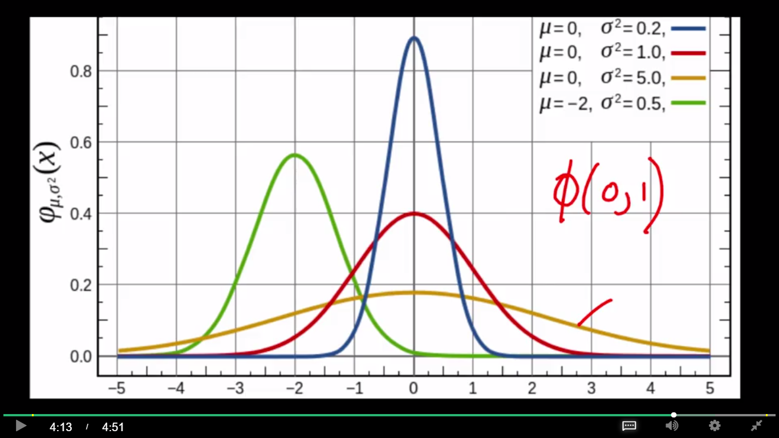

Appendix 4.3

We use the NormSDist function to calculate probability from z-scores. One of the most common practical applications is to calculate the probability of an observed sample mean using the Central Limit Theorem to give us the z-score. This requires four inputs:

Two relate to the overall population

(1) Mean of some measurement taken from a population [Cell C2] and

(2) Standard deviation for that population [Cell E4].

Two relate to the sample:

(3) Number of items "n" in a sample taken from the population (sample size) [Cell E7] and

(4) Mean value for the sample [Cell B5]

Using only these four inputs it is possible to determine *how unlikely* it is to observe the sample mean by chance alone. In other words, if the sample is truly chosen at random from the population, what is the probability of observing a sample mean as far or farther from the population mean?

Note that: SEM is usually estimated by the **sample** estimate of the population **standard deviation** (**sample standard deviation**) divided by the **square root** of the **sample size**(assuming statistical independence of the values in the **sample**): n is the **size**(number of observations) of the **sample**.

**Example**

Question. Assume a money manager selects an equal-weighting of 50 stocks from a stock market and hold those stocks for a year. If the mean annual return of all stocks in that market is 8%, and the stocks making up that that market had an annual standard deviation of excess returns against the mean return (a cross-sectional dispersion) of 20%, what is the probability that the manager’s portfolio returns 13% by chance alone?

**Answer:**

Mean value for some measurement taken from a population is [8%] .

Standard deviation for that population is [20%].

Number of items n in a sample taken from the population (sample size) is [50].

Mean value for the sample is [13%].

Standard deviation of sample means is 20%/sqrt(50) = .02828 or 2.928%.

The z-score of a 13% return is (13% - 8%)/2.828% = 1.77.

Using the Excel formula 1- NormSDist(z) [Cell B19] gives a probability of 3.85%.

There is a 3.85% probability that the manager could achieve these results or better by chance alone.

### 1.5 Central Limit Theorem

If you take a number of draws from any distribution with defined mean and defined variance, **the distribution of your sample means** is going to form a nice Gaussian distribution, Sampling distribution of the sample mean.

as the number of draws gets large  
1. The mean of our sample means will approach 0, the mean of the original distribution.

1. The standard deviation of sample means will approach 0.115, the standard deviation of the original distribution divided by the square root of 25, so here 5.
2. Even though the original distribution has a different shape, the histogram of sample means forms an approximate Gaussian distribution, here marked by the curved line.

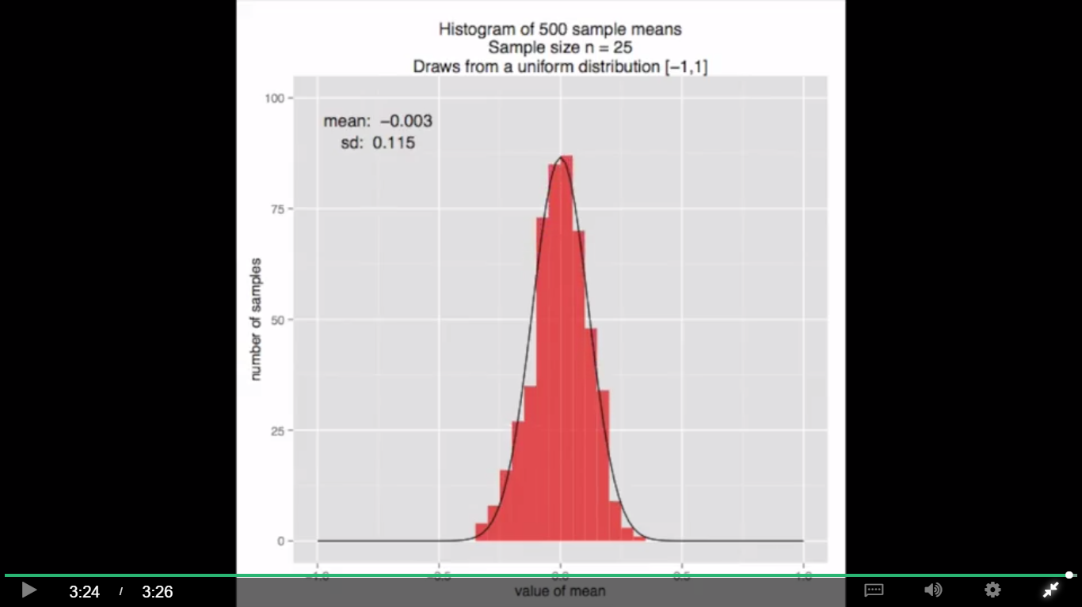

Appendix 4.4

The Excel “RAND()” function generates a random number drawn from a uniform distribution with values greater than or equal to 0 and less than 1. Therefore the Excel formula “=2*Rand()-1” generates a random number drawn from the uniform distribution with width 2 and lowest value -1.

This spreadsheet can generate draws from any uniform distribution of the form [a,b) by entering the value for a in Cell C2 and the value for b in Cell E2.

All uniform distributions [a,b) have a mean of the form a+b/2.

The uniform [-1, 1) distribution therefore has mean 0 [Cell H1].

* 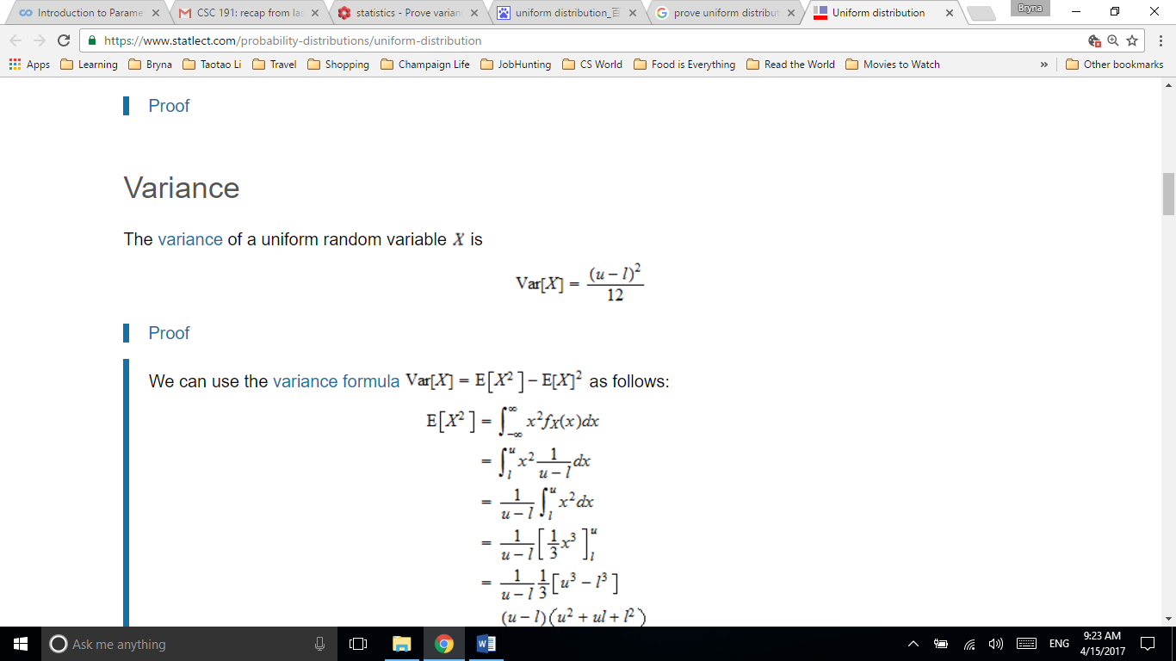

https://www.statlect.com/probability-distributions/uniform-distribution

All uniform distributions [a,b) have variance = ((b-a)^2)/12. The uniform [-1,1) distribution therefore has variance = 1/3 [Cell N2] and standard deviation = sqrt((b-a)^2)/12) = .577 [Cell N3].

Each column contains a “sample” of n = 100 values drawn at random from the uniform [-1,1) distribution [rows 23-122]. The “sample mean” for those 100 cells is given in row 13

The *Central Limit Theorem* states that the distribution of a large number of sample means – the values found in row 13 – will be approximately Gaussian, with mean approaching the mean of the underlying distribution, namely 0, and standard deviation approaching the standard deviation of the original distribution divided by the square root of the sample size.

Note: n is the sample size, is constant, and there is another n’ changing from 1 to 250

Since n = 100, and sqrt(100) = 10, for draws from [-1, 1) the standard deviation of the distribution of sample means should approach 1/(.577*10) = .0577

What do we mean by “approach”? As the number of sample means included grows large, the empirical distribution should get gradually closer to its theoretical Gaussian shape.

The mean of sample means is given in row 15. The difference between this value and the theoretical value of 0 is given in row 16. After 100 sample means, the difference is given in [Cell CW16]. After 250 sample means, the difference is given in [Cell IQ16 and Cell B9].

The standard deviation of sample means is given in row 19. The difference between this value and the theoretical value of .0577 is given in row 20. After 100 sample means, the difference is given in [Cell CW20]. After 250 sample means, the difference is still .001 [Cell IQ20 and Cell B10].

### 1.6 Algebra with Gaussians

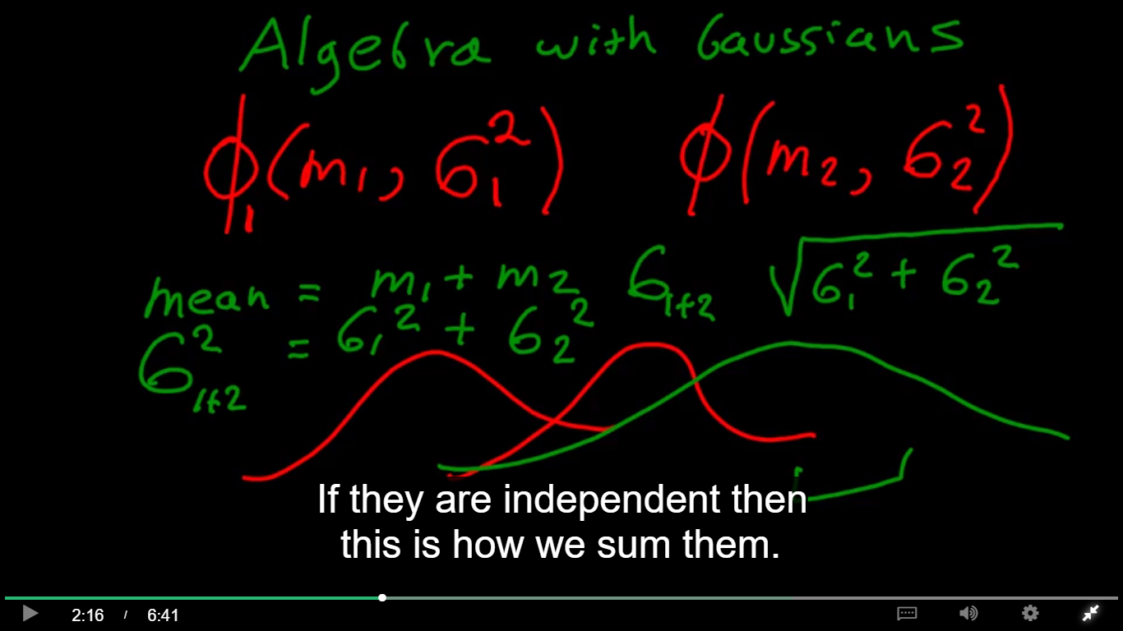

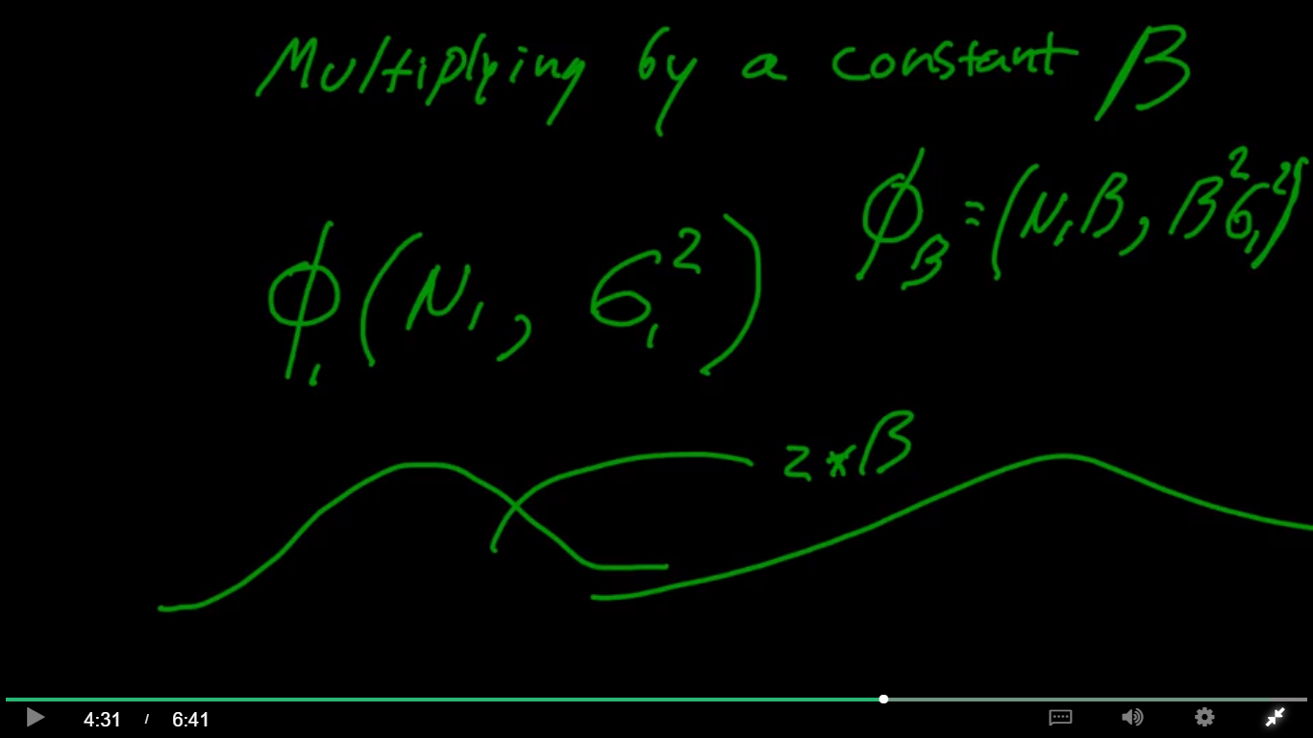

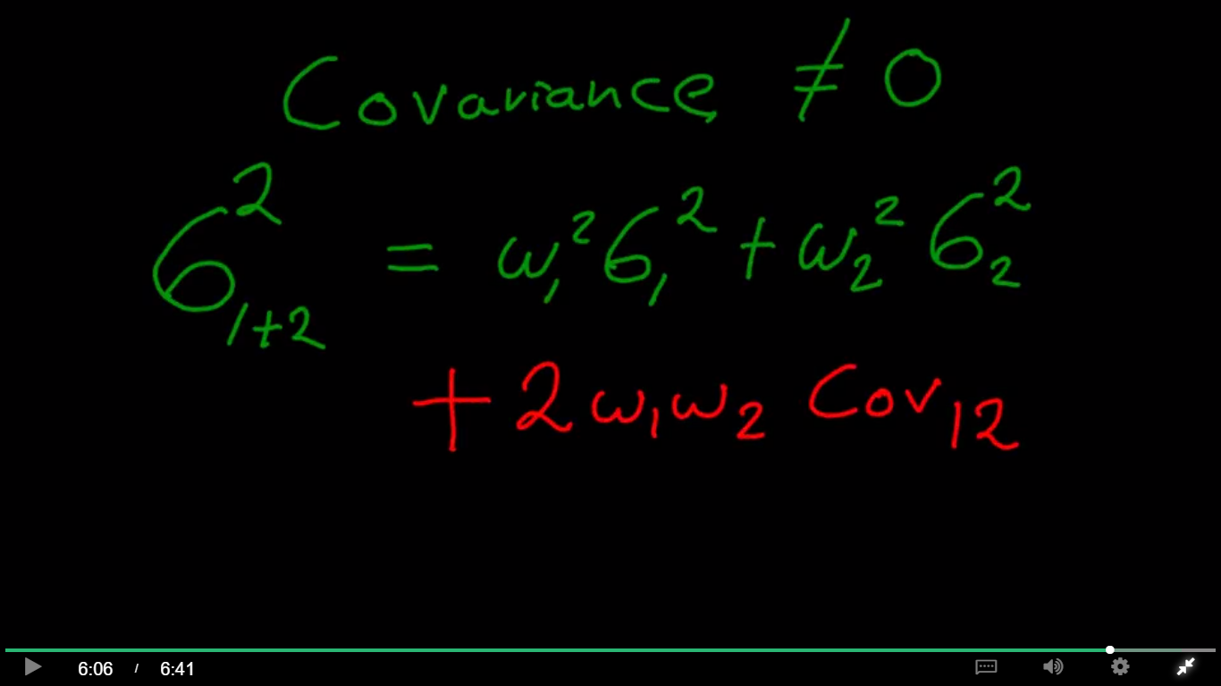

Appendix 4.5

Using the Algebra with Gaussians Spreadsheet

The new distribution formed by repeatedly combining random draws from two different Gaussian distributions, is itself a Gaussian. This is a very convenient property that is not true of other probability distributions.

We use the Greek letter Phi $ϕ$ (a, b) notation to stand for a Gaussian distribution with **mean** = a and **variance** (standard deviation squared) = b.

The spreadsheet gives three different types of ways to add two Gaussians.

**First:** if the two Gaussians $ϕ_{1 }$ and $ϕ_{2} a$ re **Independent,** their correlation R, Covariance (${Cov}_{1,2}$) and Mutual Information ($I\left(ϕ_{1};ϕ_{2}\right)$ are all 0. In that case, combining a draw from each results in a distribution with mean equal to the sum of the means, and variance equal to the sum of the variances. In Phi notation, we can write,

$$ϕ_{1}\left(a, b\right)+ϕ_{2}\left(c,d\right)= ϕ_{1+2}(a+c, b+d)$$

In the Spreadsheet, enter the mean [Cell C4] and variance [Cell E4] of the first Gaussian and the mean [Cell C6] and variance [Cell E6] of the second Gaussian.

The combined mean is given in [Cell C8] and the combined variance in [Cell E8].

**Second:** it is possible to create **weighted combinations** of the two Independent Gaussians. Most commonly, weights $w_{1}$ and $w_{2}$ are used so that $w_{1}$ + $w_{2}$ = 1, but any numbers can be used for w. In Phi notation,

$w_{1}ϕ_{1}\left(a, b\right)+w_{2}ϕ_{2}\left(c,d\right)= ϕ_{1+2}\left(w_{1}a+w_{2}c, w_{1}^{2}b+w_{2}^{2}d\right)$

In the Spreadsheet, enter the mean [Cell C13], variance [Cell E13], and weighting [Cell G13] of the first Gaussian and the mean [Cell C15], variance [Cell E15] and weighting [Cell G15] of the second Gaussian. The combined mean is given in [Cell C17] and the combined variance in [Cell E17].

**Third:** is it possible to create weighted (or unweighted) combinations of **dependent** Gaussian distributions. Dependence is expressed in terms of *Covariance*. In Phi Notation,

$w_{1}ϕ_{1}\left(a, b\right)+w_{2}ϕ_{2}\left(c,d\right)= ϕ_{1+2}\left(w_{1}a+w_{2}c, w_{1}^{2}b+w_{2}^{2}d+2w_{1}w_{2}{Cov}_{1,2} \right)$

In the Spreadsheet, enter the mean [Cell C22], variance [Cell E22], and weighting [Cell G22] of the first Gaussian, the mean [Cell C24], variance [Cell E24] and weighting [Cell G24] of the second Gaussian, and the Covariance between them [Cell F22]. The combined mean is given in [Cell C26] and the combined variance in [Cell E26].

Example.

**Question.** I create an investment portfolio that is 65% Exxon stock and 35% Tesla Stock. The stocks’ expected annual returns have a Gaussian distribution, with Exxon = $ϕ\left(10\%, .04\right)$ and Tesla = $ϕ\left(15\%, .09\right)$ and the two distributions have Covariance = .03. What is the expected return and standard deviation of the investment portfolio?

**Answer.** Use the third spreadsheet section, for weighted combinations of dependent distributions. The expected return = 11.75% [Cell C26] and the expected standard deviation of return = 20.39% [Cell D26]

### 1.7 Markowitz Portfolio Optimization

Sharpe ratio = (Mean [portfolio return](http://www.investopedia.com/terms/p/portfolio-return.asp) − Risk-free rate)/Standard deviation of portfolio return

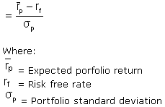

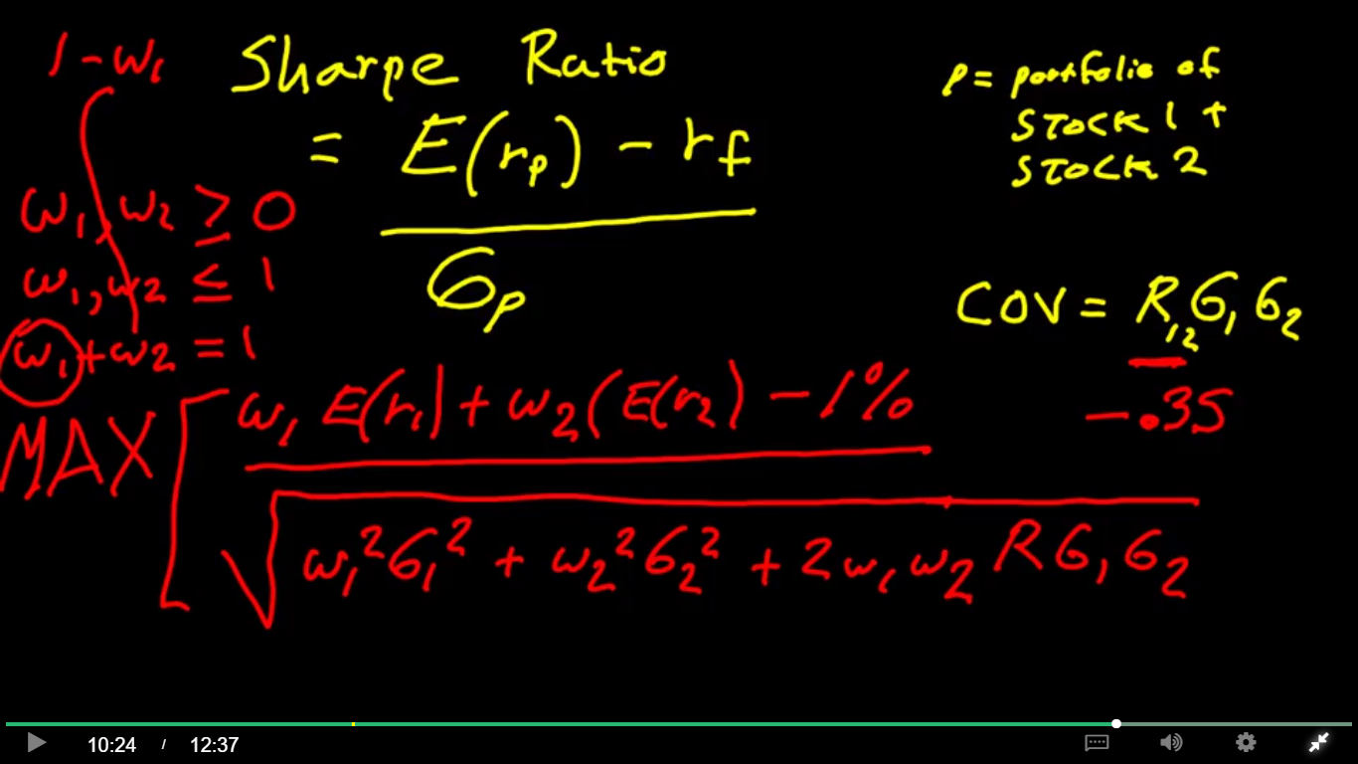

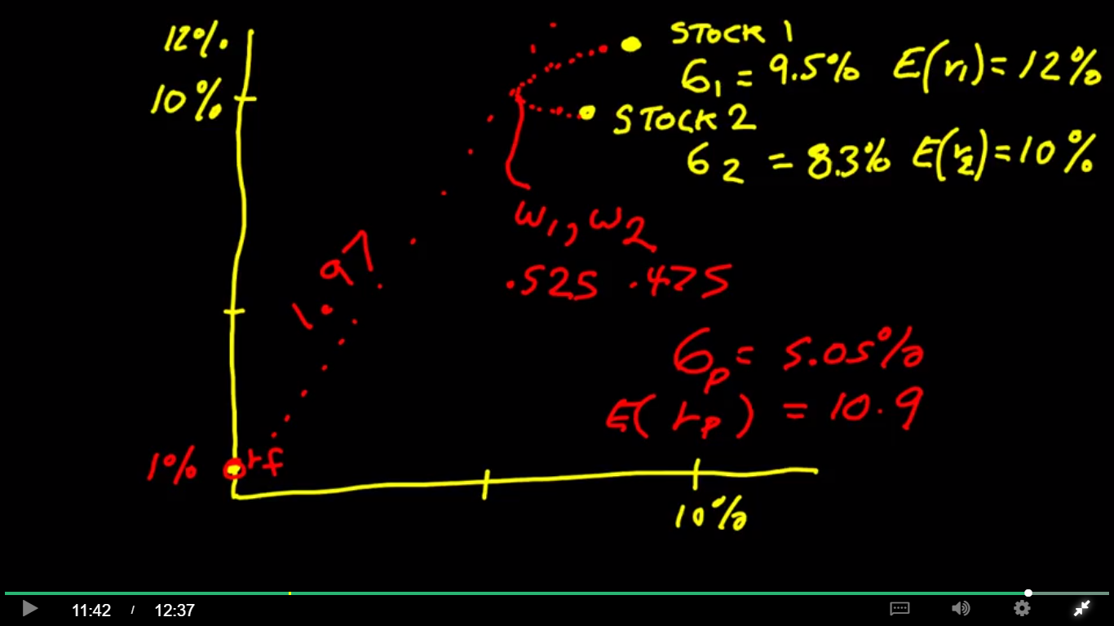

Appendix 4.6

Just like the Algebra with Gaussians Spreadsheet, the Markowitz Portfolio Optimization spreadsheet calculates the mean [Cell F12] and standard deviation [Cell E12] of the weighted sum of two Gaussian probability distributions.

In finance, it is common to represent the potential return from an investment asset over a fixed future time interval with a Gaussian probability distribution. The Gaussian’s mean is equal to the asset’s mean or “expected” financial return, and the standard deviation is equal to the estimated standard deviation of the asset’s financial returns, also called its “volatility.”

A weighted combination of financial assets held for investment is called a “portfolio.” The portfolio is also represented as a Gaussian, with combined mean equal to the portfolio’s expected return, and standard deviation equal to the portfolio’s estimated volatility.

The Markowitz Portfolio Optimization Spreadsheet includes an additional financial input: the “risk free rate” which is the return earned by a zero-volatility (“risk free”) asset such as a U.S. government short-term bond [Cell G8].

And it outputs an important financial performance metric: the “Sharpe Ratio.” [Cell G11]. The Sharpe Ratio is defined as the difference between the portfolio expected return, and the risk-free rate of return, divided by the portfolio volatility (standard deviation). Maximizing the Sharpe Ratio is a combined profitability and risk metric that ensures the highest return over the risk-free rate for each unit of volatility (risk) over the zero-volatility risk free asset.

**Examples**

Question 1. What is the portfolio weighting the maximizes the Sharpe Ratio? What is the portfolio return, volatility, and Sharpe Ratio at this maximum?

Answer 1. Use MS Solver to set [Cell G11] to a maximum by changing the asset weighting [Cell C9] subject to the constraints that 0 < C9 < 1. At a portfolio weighting of .53, .47, the portfolio return is 10.9%, the portfolio standard deviation is 5.1%, and the Sharpe Ratio is 1.97.

Question 2. Change the risk-free rate to 2% and the expected return of Asset A to 9%. What is the new portfolio weighting the maximizes the Sharpe Ratio? What is the new portfolio return, volatility, and Sharpe Ratio at this maximum?

Answer 2. At a portfolio weighting of .51, .49 the expected return is 10.5%, the volatility is 5.1% and the Sharpe Ratio is 1.67.

## Unpacking Linear Regression

### 2.1 Standardizing x and y Coordinates for Linear Regression

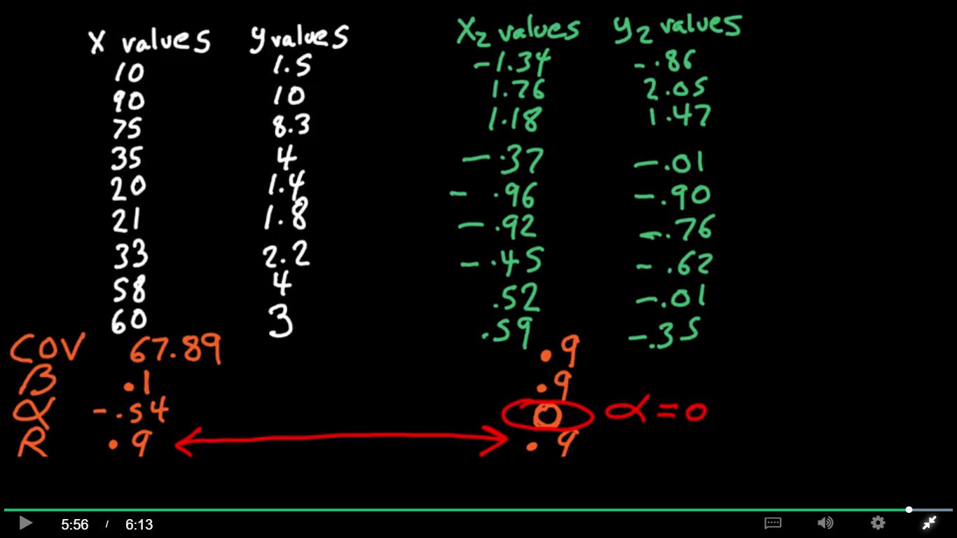

### 2.2 Standardization Simplifies Linear Regression

we're trying to minimize the sum of squared errors to get the best fit line

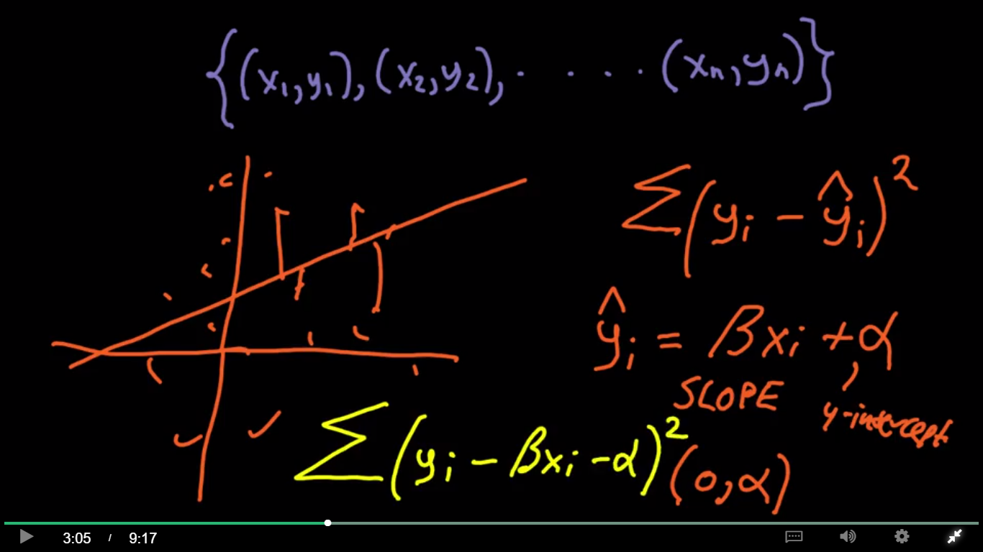

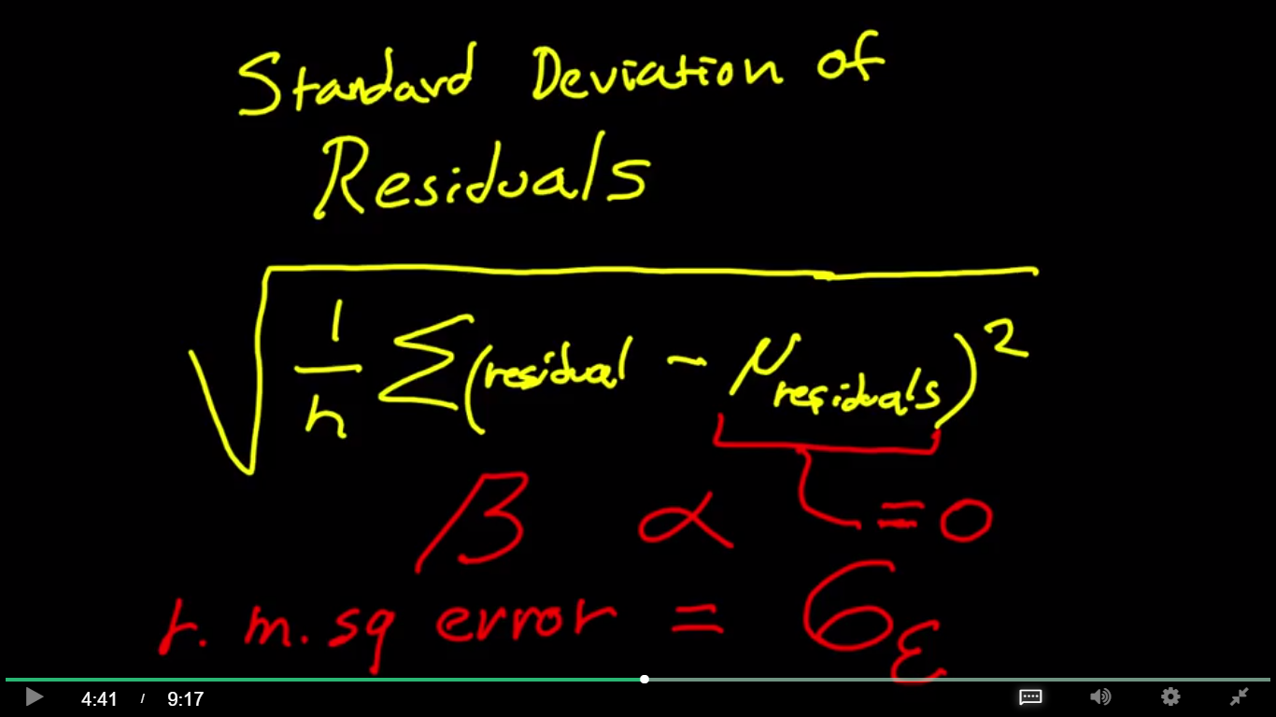

For the best fit line, the mean residual is always equal to zero.

What that means is that the root mean square error is the same thing as the standard deviation of the errors

when you convert x and y, the ordered pairs, into standardized values, or z scores, the slope of the best fit line beta is equal to R, which is equal to the covariance.

B = R = Cov

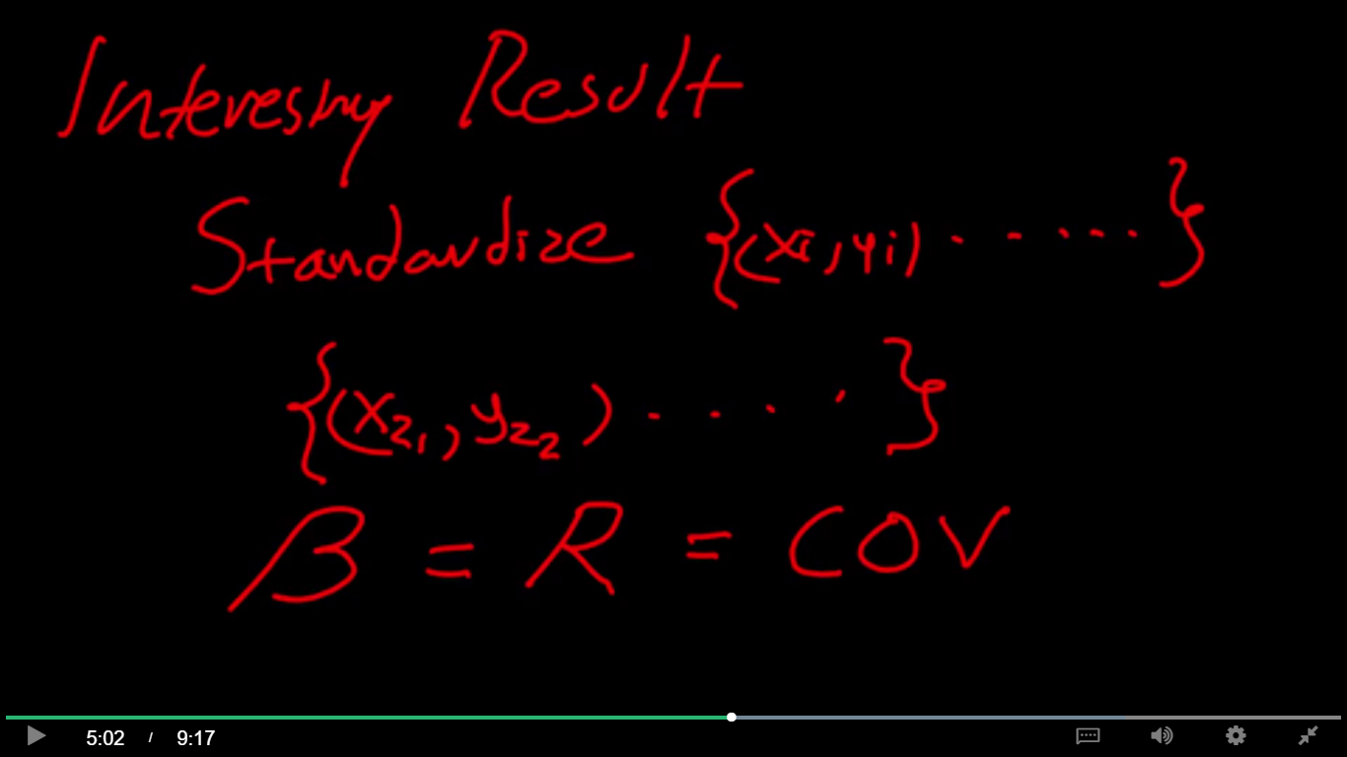

### Modeling Error in Linear Regression

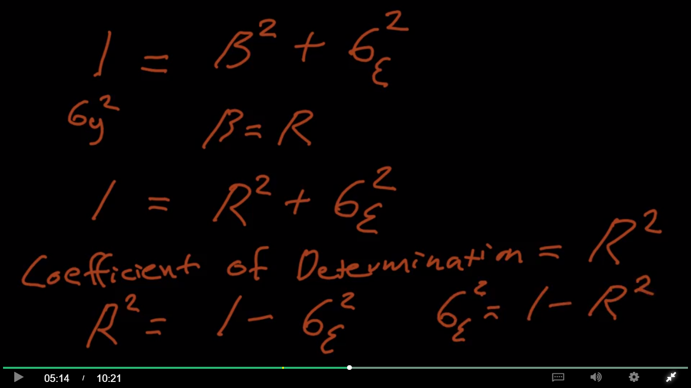

There is a direct relationship between the standard deviation of our errors and the correlation

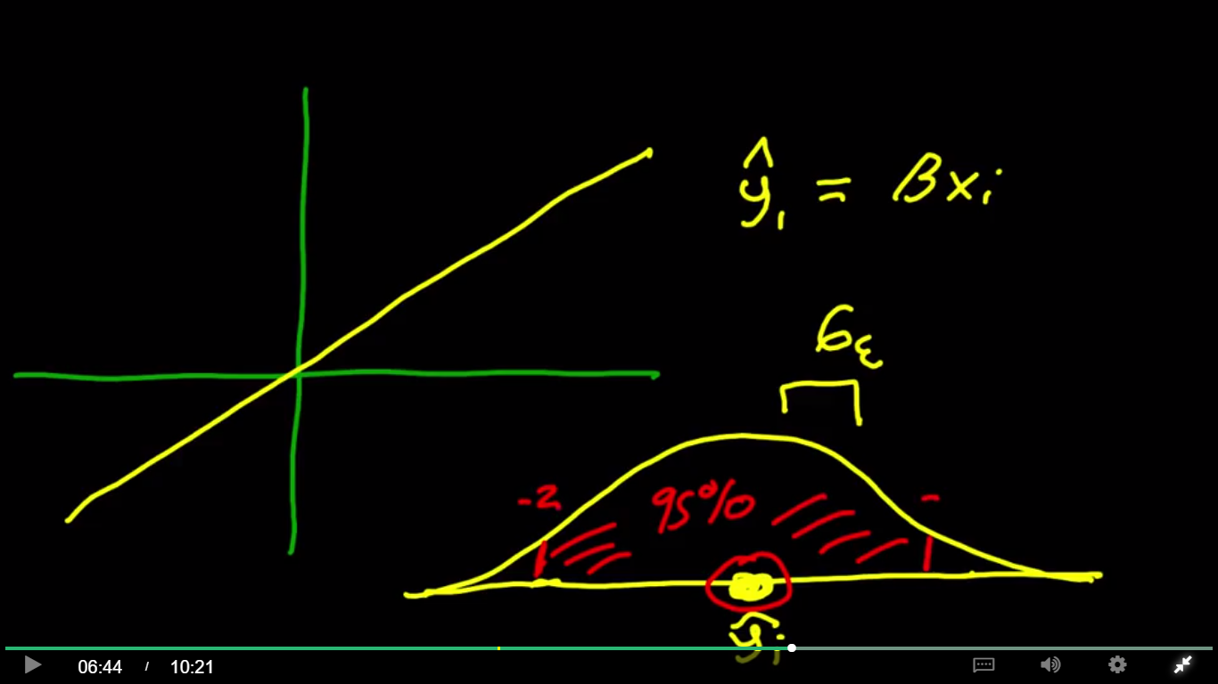

We would like to know what that error is, so that we can give not only a point forecast, but actually a forecast that's in the form of a probability distribution, where the mean is our estimate for Y sub i, and we have error around that point. And the standard deviation is equal to the standard deviation of our residuals. And this allows us to be very precise, for example, to say we have a maximum likelihood point, but what we're really saying is perhaps we have a 95% confidence that the value will be between these different Z-values.

When no association: correlation = 0. There really is no line, the line is flat. The standard deviation of y = 1, and the standard deviation of our error = 1.

At the other extreme, would be our perfect model where R = 1, there would be no error at all.

And this would mean that every single value actually was on this line.

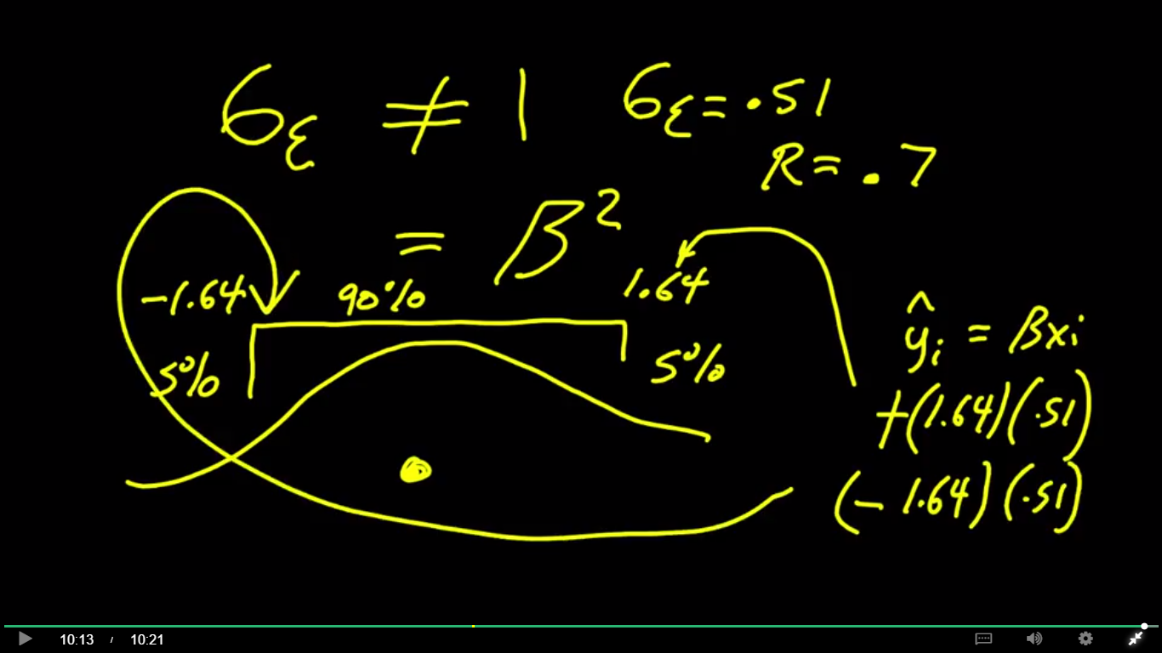

Append 4.7

How to use the Correlation and **Model Error** Spreadsheet

This Spreadsheet demonstrates how, starting with a specific input $x_{i}$, a linear regression model with standardized variables can be used to make two different types of forecasts or estimates,

A *Point* Forecast: $\hat{y_{i}}=$ $βx_{i}$, and

A *Probabilistic* Forecast: $ϕ\left(βx_{i}, 1-β^{2}\right)$.

Note that $(1-β^{2}$) can also be written as $σ_{ε}^{2}$, notation for “the variance of the model error.” So an equivalent way to represent the probabilistic forecast is $ϕ\left(βx_{i}, σ_{ε}^{2}\right)$.

Since the linear function for standardized variables can also be expressed $y=Rx$, yet a third equivalent way to represent the probabilistic forecast is $ϕ\left(Rx_{i}, 1-R^{2}\right)$.

In other words, the probabilistic forecast takes the form of a Gaussian probability distribution function with mean = $Rx_{i}$, variance = $1-R^{2}$, and standard deviation = $\sqrt{1-R^{2}}$. The advantage of the probabilistic forecast is that it allows one to specify the probability that the true result will fall within a certain range around the mean – a “confidence interval.”

**Example 1.** Assume a standardized linear regression model has correlation R = .5 [Cell I38] and the point $x_{i}$ = .8 [Cell I36]. The point forecast $\hat{y_{i}}$ = $Rx_{i}$ = .4 [Cell I40]. This value is also the mean of the Gaussian probability distribution. The standard deviation of the Gaussian is $\sqrt{1-R^{2}}$ = .87 [Cell H46].

Assume one wants 50% confidence [Cell F46] that the true answer would fall within a defined range. Calculated in Excel, the range to specify would over the interval from

$Rx_{i}$– (NormSInv(.75) $\sqrt{1-R^{2}}$) to

+ (NormSInv(.75) $\sqrt{1-R^{2}}$])

This range, from -.18 [Cell I46] to .98 [Cell K46] is known as the “50% Confidence interval.”

**Example 2.** Assume the correlation is R = .353 [Cell I 38] and the value of $x_{i}$ = .09 [Cell I36].

Q: What is the mean of the probabilistic forecast?

Answer: .0318 [Cell I40].

Q: What is the 99% Confidence Interval? [Cell F50].

Answer: from -2.38 [Cell I50] to 2.44 [Cell K50].

### Information Gain from Linear Regression

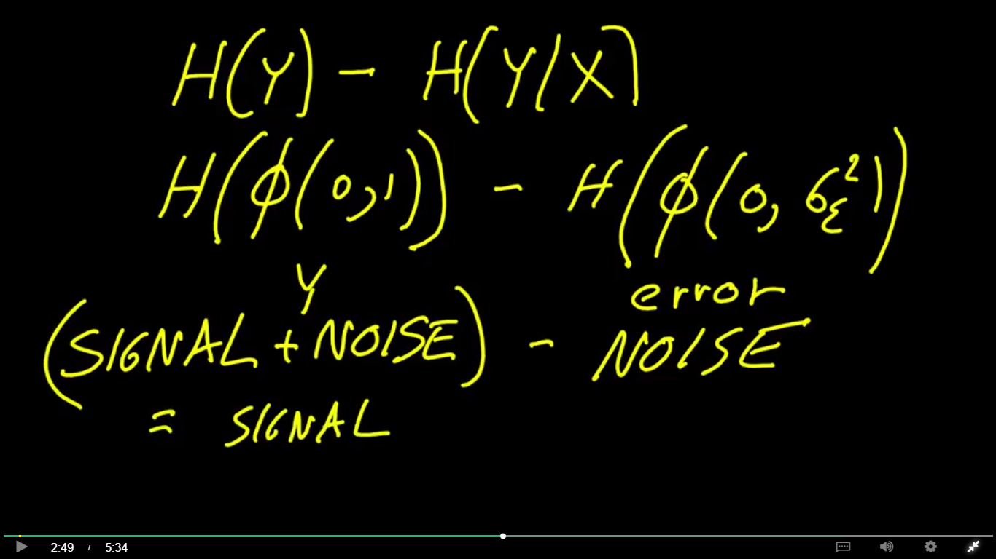

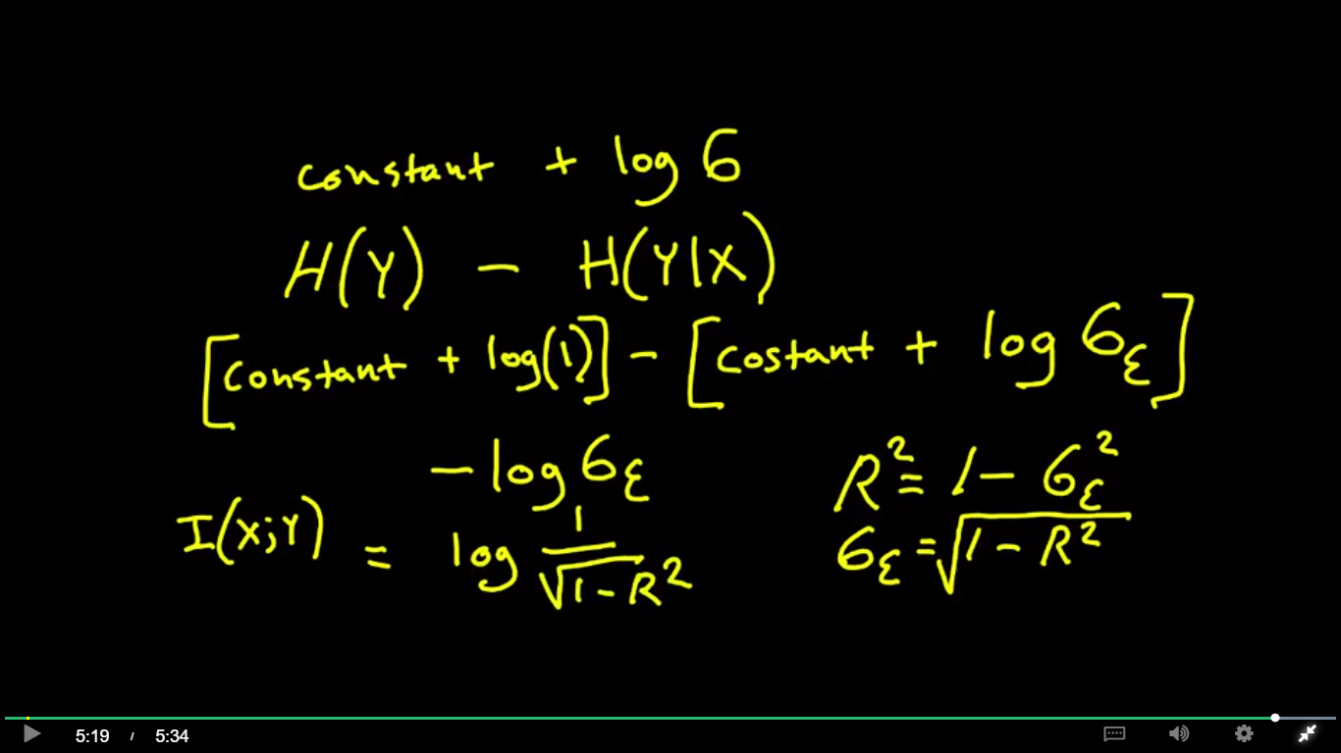

Appendix 4.8

**How to Use the Correlation and P.I.G. Spreadsheet**

We assume standardized random variables X, Y with Gaussian distributions.

Use this spreadsheet to input any linear correlation R into any row of Column B.

The equivalent Percentage Information Gain (P.I.G.) will be output in Column G.

For example – input R = .387. Output will be 5.9%.

Why does a linear correlation correspond exactly to one Percentage Information Gain? Well…

Percentage Information Gain

= I(X;Y) / H(Y)

= H(Y) – H(Y|X) / H(Y)

[(the original entropy) – (the entropy of the model error)] / [the original entropy]

= H(Gaussian with standard deviation 1) – H(Gaussian with standard deviation $\sqrt{1-R^{2}}$) / H(Gaussian with standard deviation =1).

= (2.05 – (2.05 + (log2($\sqrt{1-R^{2}}$) ) / (2.05 )

= – (log2($\sqrt{1-R^{2}}$)/2.05)

The formula in Column G.